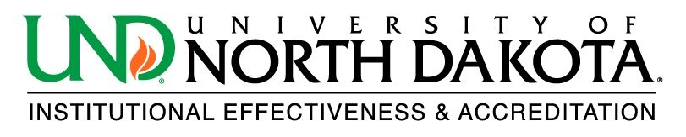

Program Reactivation Form

Program Name: Click or tap here to enter text.

Degree Level (MA, BA, certificate, etc.): Click or tap here to enter text.

- Was this degree program active during the last HLC visit (2013-2014)?
  - Yes☐ No☐

- Is the curriculum of the reactivated degree program exactly the same as the degree program that was deactivated?
  - Yes☐ No☐

- Has the reactivated degree program’s method of delivery changed (Online, on-campus, etc.)?
  - Yes☐ No☐

- Has there been an aggregate change of 25% or more of the required courses (curriculum content) of the degree program?
  - Yes☐ No☐

- Has there been a substantial increase or decrease in the number of clock or credit hours required for successful completion of the degree program?
  - Yes☐ No☐

- Has there been a change in the manner(s) in which the degree program measures student progress, regardless of method?
  - Yes☐ No☐

Please email the completed form to: und.hlc@und.edu

