University of North Dakota Self-Paced Enroll Anytime

Final Grade Submission in Campus Connection

Once a student completes your course and you have assigned their final grade in Blackboard, please promptly enter their grade into Campus Connection so their transcript is processed in a timely manner.

# How to access your final grade roster:

1. Log in to Campus Connection via the Logins tab on the main UND homepage. Sign in using your NDUS login.
2. From the Faculty/Advisor Homepage, click on Faculty Center
   * Click on My Schedule
3. On the main page that is displayed in **Faculty Center**:
   * Ensure you are in the proper term for which that student is enrolled. If unsure which term that student is enrolled, refer to the Term column for that student in the Blackboard Grade Center (Original) or Gradebook – Grades panel (Ultra). See the term numbers listed below.
   * If you need to change the term, from the main page in Faculty Center, click the **Change Term** button and select the appropriate term.
   * Click on the Grade Roster icon to the left of the course you wish to enter grades.
   * When the roster screen appears, make sure the roster type is **Final Grade**. If it is not, click the roster type drop down box and select Final Grade. This will bring up the Final Grade roster.

# How to enter final grades:

1. In the correct student row, click the Roster Grade dropdown and select a grade for the student.
2. **Always leave your SPEA course roster status as “Not** **Reviewed”** (this is different from regular semester-based final grading and will allow us to add future students to your roster). Do NOT “approve” the roster.
3. When grades have been entered and are correct, click **SAVE** at the bottom of the screen.
4. **Note:** Students who purchase a 3-month extension on their course will already

have an “I” grade listed in the grade roster. This will prevent you from entering a final grade. Once those students complete the course, notify [und.courses@und.edu](mailto:und.courses@und.edu) with the final grade and the student’s name. We will submit a final grade form to the Registrar on your behalf. You will not need to take any further action.

# SPEA Terms—the term code is listed in your Blackboard Gradebook/Grade Center and translates to the following UND semesters:

|  |  |  |
| --- | --- | --- |
| 2410: Fall 2023 | 2430: Spring 2024 | 2440: Summer 2024 |
| 2510: Fall 2024 | 2530: Spring 2025 | 2540: Summer 2025 |
| 2610: Fall 2025 | 2630: Spring 2026 | 2640: Summer 2026 |

(-10 indicates Fall, -30 indicates Spring, -40 indicates Summer of the Fiscal Year)

# Faculty Center button in main Campus Connection menu:

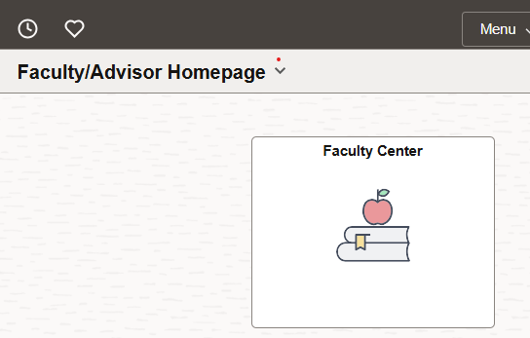

# Term view and Change Term button in Faculty Center. Click the highlighted icon to access the Grade Roster:

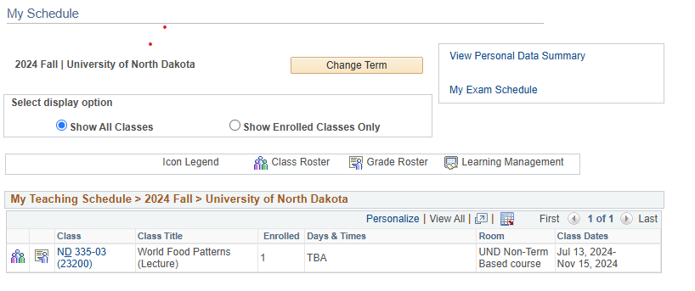

# Grade Roster view—note the Final Grade and Not Reviewed are selected under Display Options and Grade Roster Action. Below this view you will see all students in your SPEA course for that term. If you don’t see the student whose grade you are entering, you are likely in the wrong term.

