# **University of North Dakota Self-Paced Enroll Anytime**

# **GETTING STARTED WITH YUJA: A quick-start guide for students**

YuJa is UND’s platform for hosting and sharing videos, audio recordings, and other digital media. It allows users to record and share content that can be used as part of course curricula, such as lectures and video assignments. Students can access the course materials on their own schedule, enabling them to review core concepts through lecture recordings and subject-specific multimedia content.

If your course includes a presentation or has you submit audio or video content, you will need to use the YuJa system to share that media. YuJa offers a *Software and Browser Capture* tool, allowing you to record video from your webcam, screen, or both. Using the YuJa app for mobile, you can record anywhere, even without an internet connection.

You may also create your recording with your own software and upload it to YuJa if it meets the file size requirements.

## HOW TO ACCESS the YUJA system

There are two ways to access the YuJa content for your course: Inside your Blackboard course site, where you will be taken directly to that course’s video library, or you can log in to the [UND YuJa website](https://und.yuja.com/) directly using your browser of choice.

### Details and Actions panel in Blackboard Ultra. Select "view course & institution tools" and select "UND YuJa" from the options. Option 1: Access YuJa via Blackboard from Inside a Course Site

First, log in to [Blackboard](https://blackboard.und.edu/) and navigate to your enroll anytime course. Look for the course menu on the right side of the page. Select "view course & institution tools" and select "UND YuJa" from the options.

Note: If your course is in Blackboard Original, with a menu bar on the left side of the page, then proceed to Option 2 to access YuJa through UND’s website.

### Option 2: Access YuJa Directly from the UND YuJa Website

Go to UND’s YuJa homepage using your browser. It’s even mobile-friendly! Near the top-right corner of the page, make sure *UND Credentials* is selected, and click *Login*. You will be prompted to log in with your NDUS.Identifier - the same username and password as your UND email and Blackboard account. Once you’re logged in, you will be taken to the University of North Dakota’s YuJa homepage, where you can *create recording*s, and *upload*,and *manage* your video and audio content.

**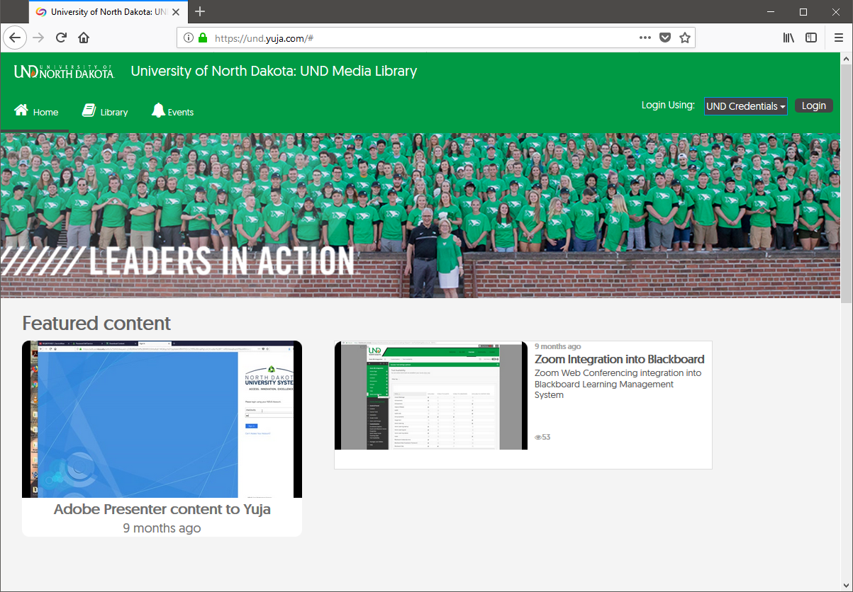**

## CREATING RECORDINGS

Once you have logged in and gotten familiar with YuJa’s basic layout, it’s easy to branch out and create a recording of your own. To get started, you will need to download the Software Capture application.

### Download the Capture Software

At the top of the YuJa homepage, click *CREATE RECORDING* for the first time, and it will prompt you to *Download* *and install* the recording software (available for Mac and PC). After it’s installed, clicking *START* from that pop-up will automatically open the desktop application.

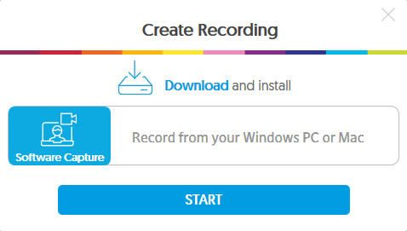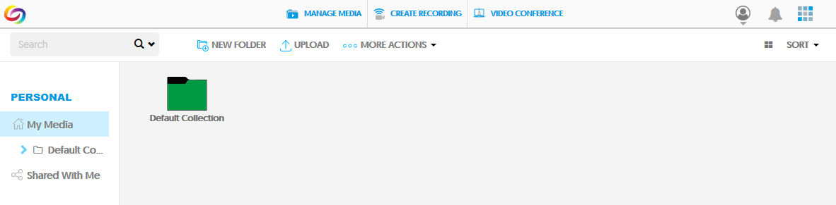

### Recording with YuJa Software Station

* Log in to [YuJa](https://und.yuja.com/) (und.yuja.com) or click on the YuJa menu item in your Blackboard course.
* Select *CREATE RECORDING***.** If you have not already downloaded the YuJa Software Station on your computer, you will need to do this prior to your first recording. Note: YuJa uses significant computer processing memory, so it is recommended to close all applications that are not necessary.
* Click the *START* button. The YuJa recording software will now open. Launch the Application. A preview screen will appear.

#### Set up your capture

1. 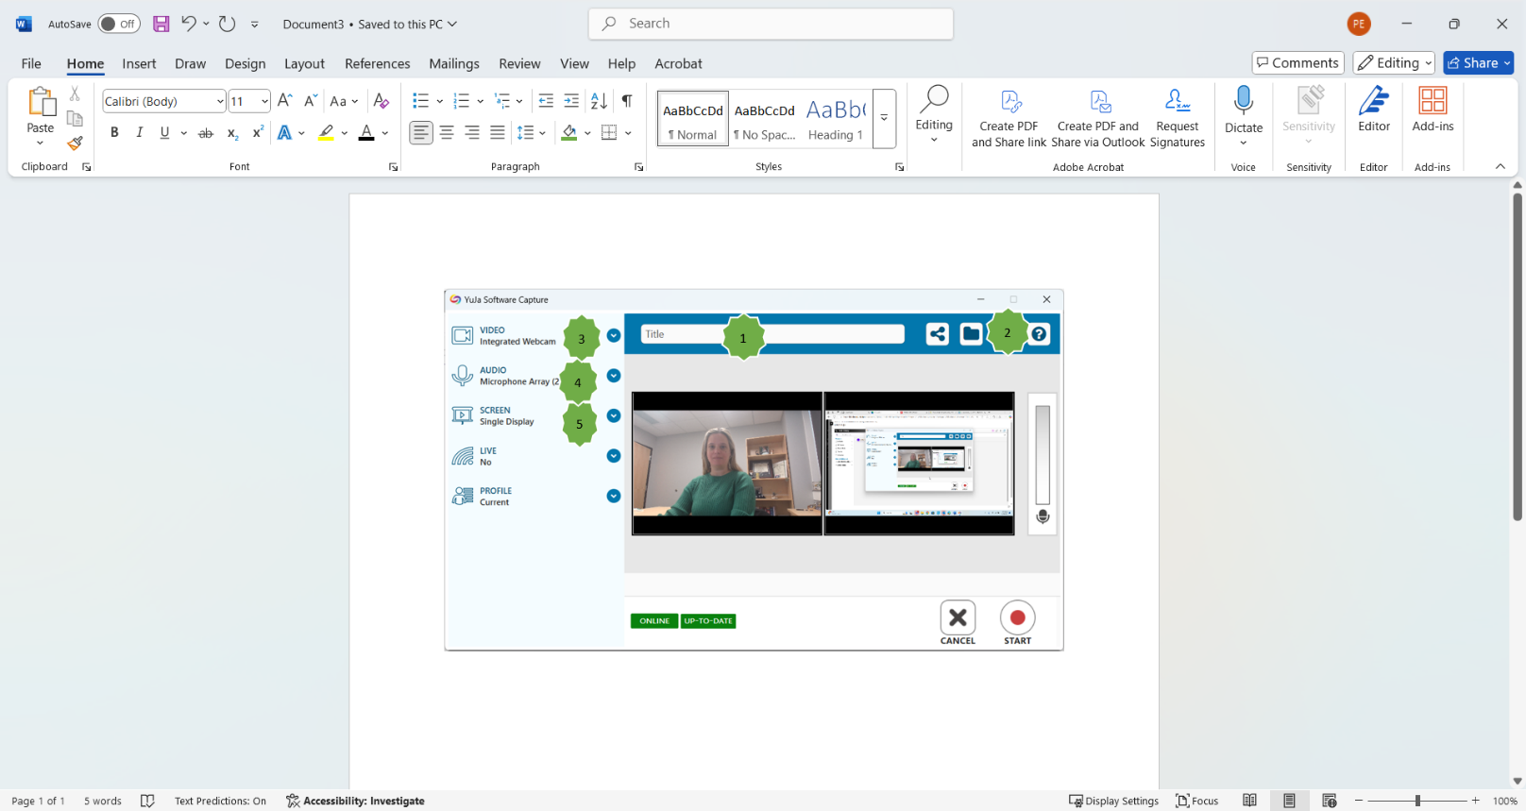Give the capture a title if you would like (or you can do this after recording). The default file name is “My Event on…”
2. Click the folder icon to choose where to save your file. The share icon allows you to select the course media channel that you are wanting to post/publish the capture in. If none are selected, or this button is not used, the recording will be placed in your default content collection folder within YuJa.
3. Select your video source(s)
4. Select your audio source(s)
5. Select your screen capture area
6. Click *START*. There will be a three second countdown before your recording will begin.

* 2019-02-26_9-17-36As you are recording, you will see your controls in the bottom right corner of your screen. It will give you the option to open the YuJa Software Station in full preview mode, stop or pause your recording and looks like this:
* When you are done recording, you will click the stop button (or press Ctrl + Shift + F). The screen below will appear where you can either *POST NOW* (if you have chosen the option to post to a specific media channel), *SAVE* (without posting to a channel) or *DELETE* your capture
* After you save, YuJa will process the recording. When the processing has completed, you will receive an email notification. Also, you will receive a separate email notification when the auto-captioning has completed. **This process may take several minutes depending on the size of the recording.**
* 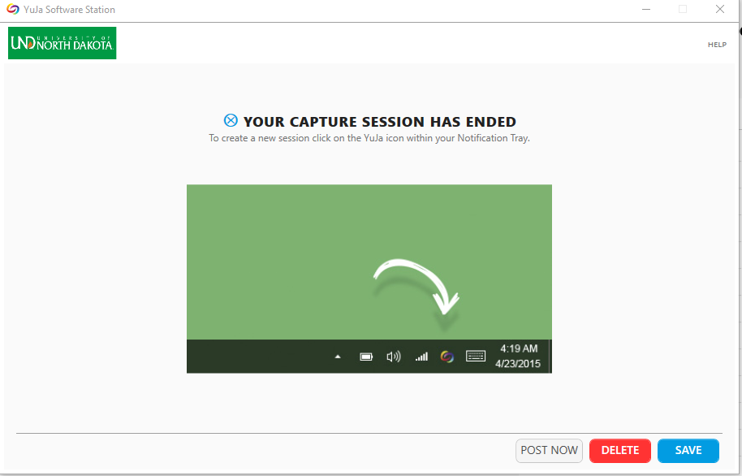After the video has processed, it will be available in the previously selected media channel or folder. The default location can be found by locating *My Media* (in the left navigation bar), then click the folder titled *Default Collection*.

## UPLOADING FILES FROM YOUR COMPUTER TO YUJA

### Supported File Types and Size Limits

Every student is allotted 10 GB of storage space on YuJa. You can upload a variety of file types, including video and audio files using one-click drag-and-drop technology, or by simply browsing to the desired file. The upload interface also supports links, document uploads, and sharing files from Vimeo or YouTube. Uploaded files may be auto-captioned, edited and accessed in the same way as a file created using Software Capture.

### Uploading Media

To upload your files, click *MANAGE MEDIA* (1) at the top of the YuJa homepage. A pop-up will open, where you can browse to select your media, or drag and drop files directly from a window on your computer.

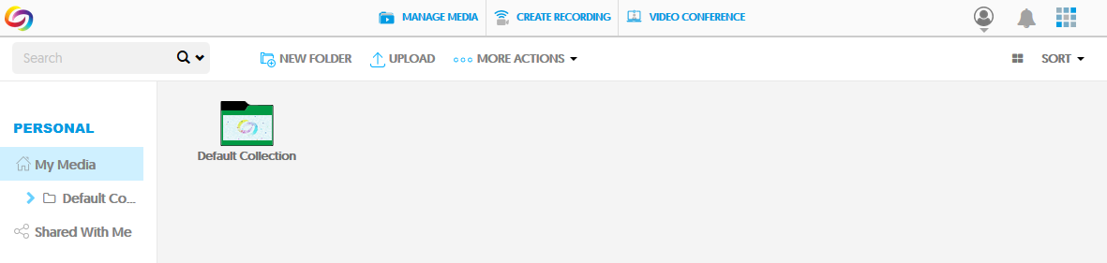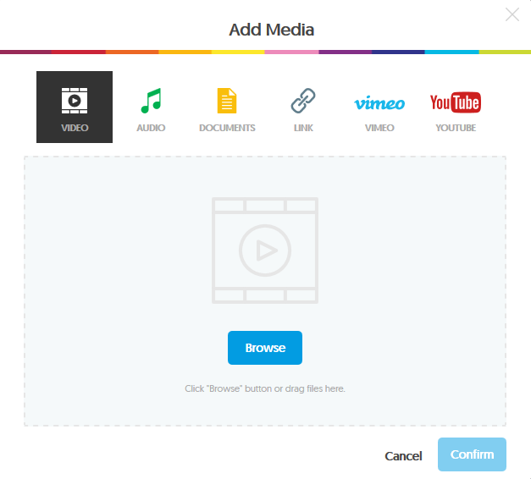

**1**

**2**

**3**

**4**

*The file must be under 5GB. Supported formats include: .wmv, .asf, .wma, .flv, .f4v, .f4a, .avi, .mp3, .mpg, .mpeg, .mps, .ps, .mp2, .m2v, .m2a,.ts, .tsv, .tsa, .mts, .m2ts, .mod, .tod, .mp4, .m4a, .m4v, .3gp, .mov, .mts (AVCHD), Flash video, .webm, .mxf, .dv*

1. Choose the type of file you want to upload (2) from the varieties listed along the top of the window: video, audio, documents, link, Vimeo, or YouTube.
2. Click *Browse* (3) to browse your computer and locate the file(s), or simply drag and drop the file(s) from another open window.
3. Edit the title and description, add captions or tags (optional), and publish the file to a course’s media channel (optional – some instructors may accept group work or assignments in their course channel).
4. When the file upload is complete, click *Confirm* (4), and the file will appear in your YuJa media library.

## SHARING YOUR MEDIA

Now that your video has been saved to your YuJa media library folder, it’s easy to share it with your instructor.

### Sharing A Direct Link To Your Video Or Folder

Direct Links enable you to share media with anyone, even individuals without YuJa accounts. You can access Direct Links for both individual media and for folders containing media.

* Navigate to the desired video in *My Media.* Mouse over the video thumbnail and click *More*.
* Select *Links*.
* Copy and paste the *Direct Link* to your video as desired.
* The same process can be followed to share direct links to your media folders.

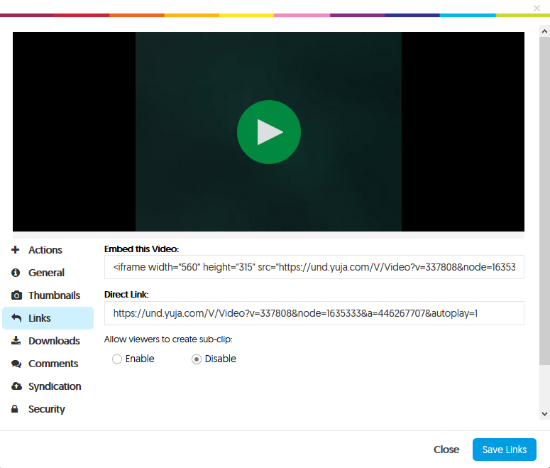

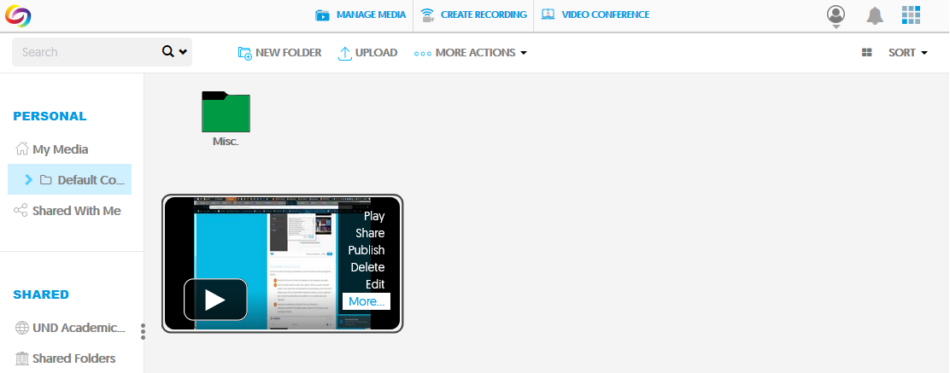

## Submitting Your YuJa Video in Blackboard Ultra

In the assignment submission box, select “Insert content” on the far right of the menu bar.

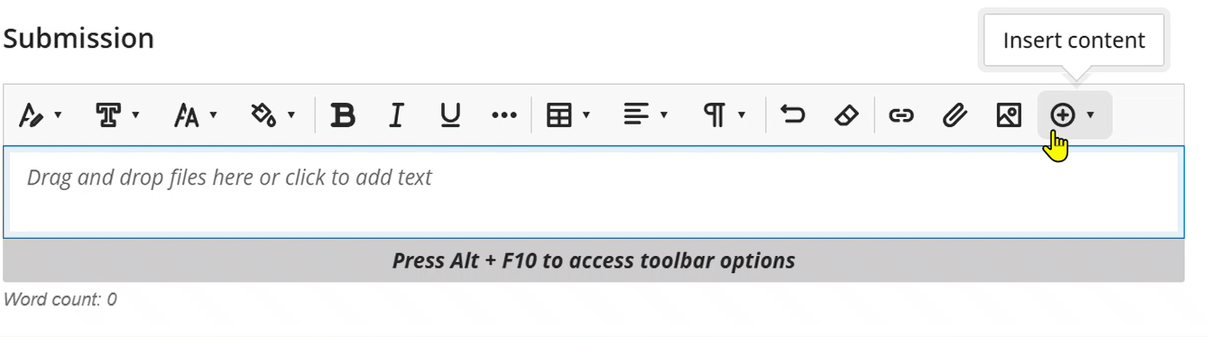

Choose “Media” from the list of options.

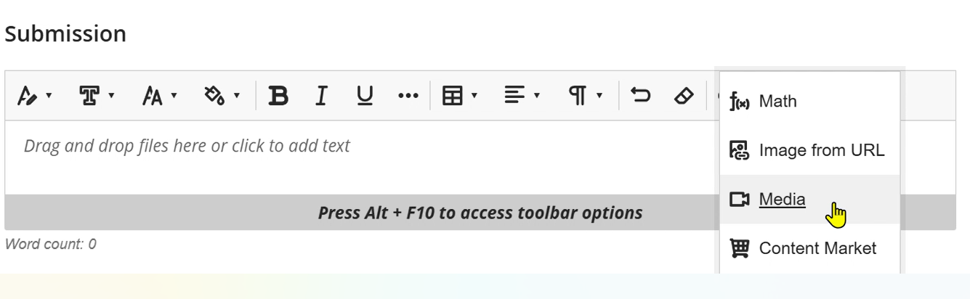

Paste your YuJa direct link into the URL box and click “Insert.”

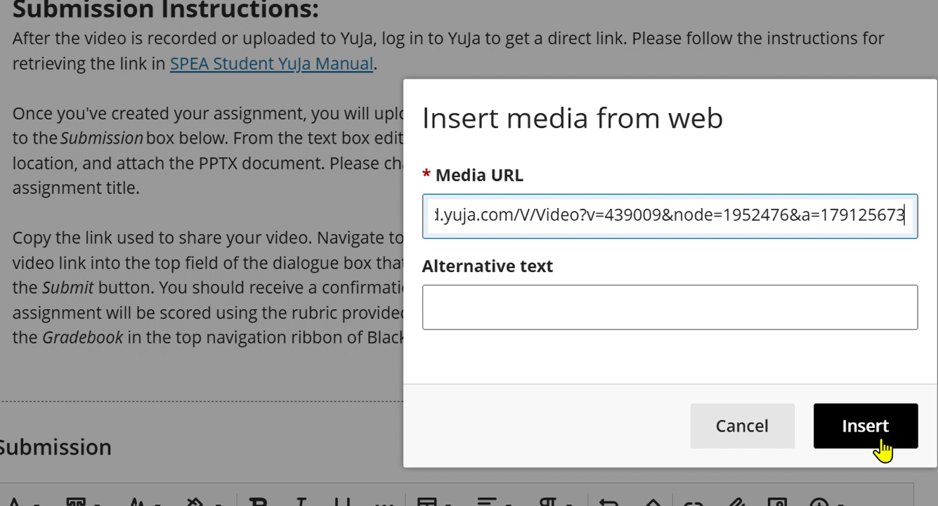

Your video will appear in the Submission box. When you are ready to submit, click “Submit” in the bottom right corner of the screen.

## ADDITIONAL INFORMATION

Have a question that hasn’t been answered here? Want to learn more about YuJa, including advanced tools and features? For more information and expanded user guides, check out [UND’s Knowledge Base](https://und.teamdynamix.com/TDClient/KB/Search?SearchText=%23YuJa) – search ‘#YuJa’. *Please log in for best service and student-centric Knowledge Base articles.* [YuJa’s Help Center](https://help.yuja.com/knowledgebase_category/quick-start-for-students/) is another great resource, with guides for everyone from beginners to advanced users.