Page 2 – Approval Process for Faculty
This guide details the Page 2 approval process for faculty. A separate guide is available for data entry and revisions.
Updated: December 8, 2025

The approval process begins at a date determined by the provost’s office. Please consult the Faculty Affairs website for information on due dates for the academic year.
- Once the workflow is initiated, you will receive an email to your UND email address. Please allow up to 24 hours for this email. The email will be coming from Watermark. If you have not received the email within 24 hours of the workflow initiation, please check your spam/junk folder.

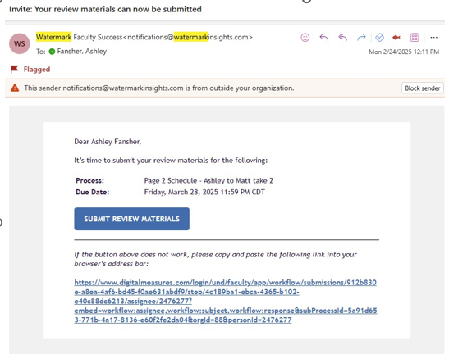
Alternatively, you can access the approval process by logging into Faculty Success and viewing your “Home” page. If the Page 2 is ready for your review, it will be in your “Tasks & To-Dos.”
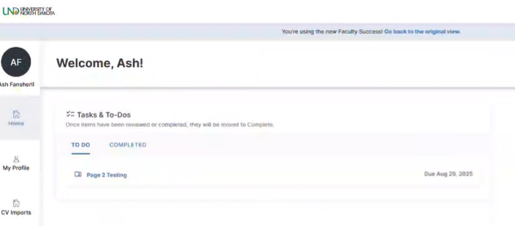
- Click the PDF icon to review your submission. You are encouraged to download the Page 2 for your records.

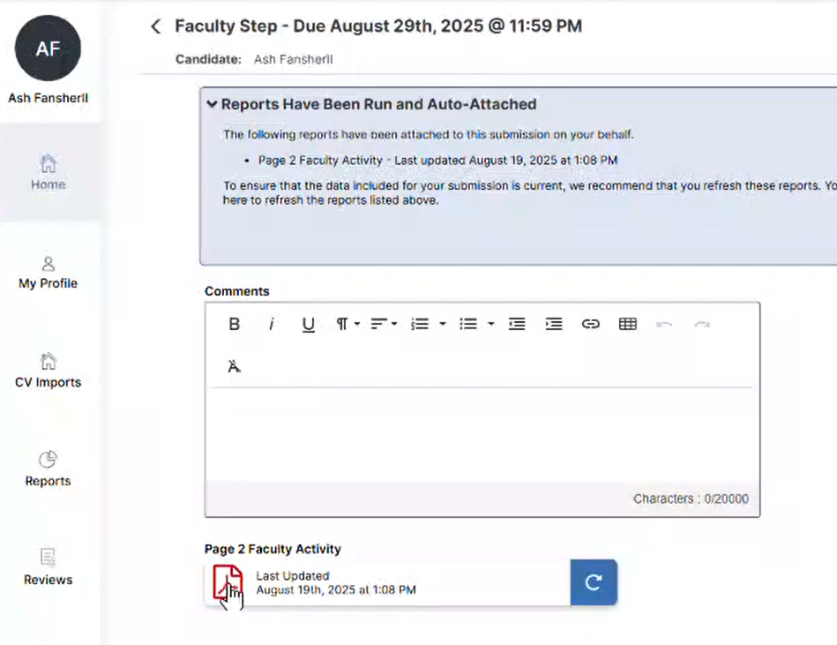
- Review the percentage numbers and confirm that the final total percent effort equals 100%.
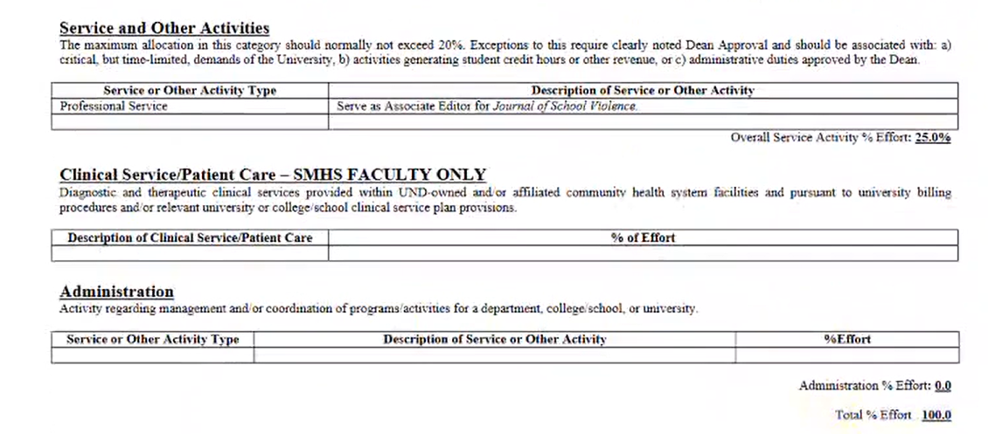

- To get out of the PDF, go back to “Home,” and click the Page 2 in your To-Do list.

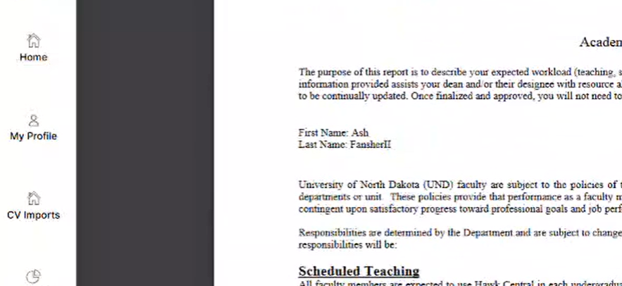
- If you need to make changes to your Page 2, you may do that now. Click “My Profile.”
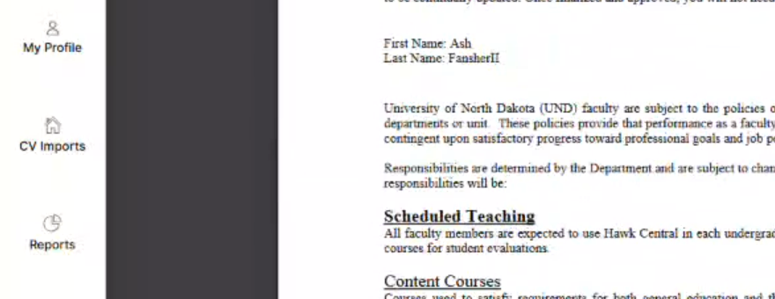
- Scroll down to find Page 2 [Future Goals].
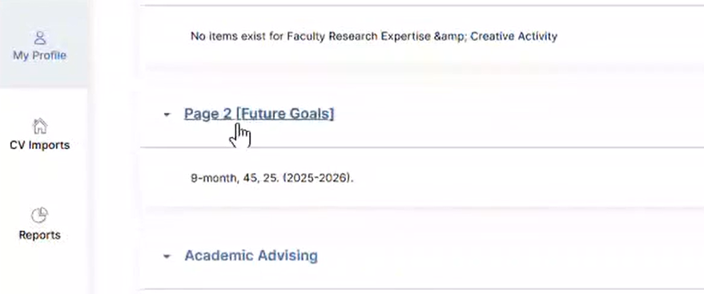

- Click the edit button on the far-right side of the respective Page 2.
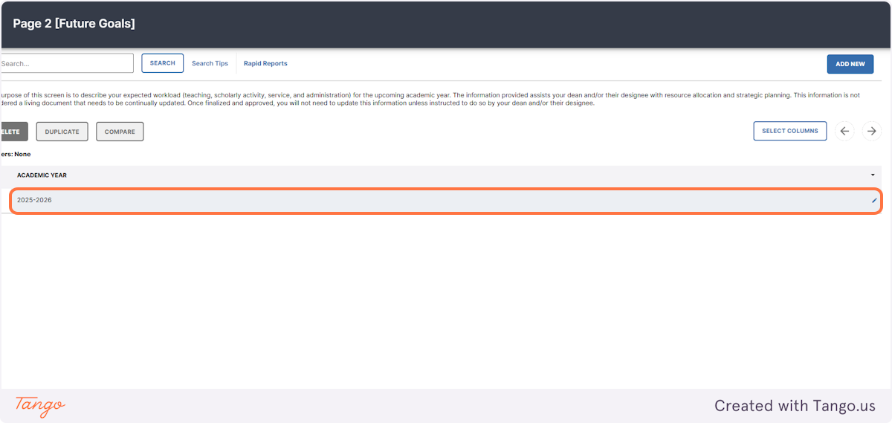
- Make the appropriate changes and select Save at the bottom of the screen.
- Return to the Home page and reenter the Page 2 under your To-Do list.
- Click the circular arrow icon to refresh the report.
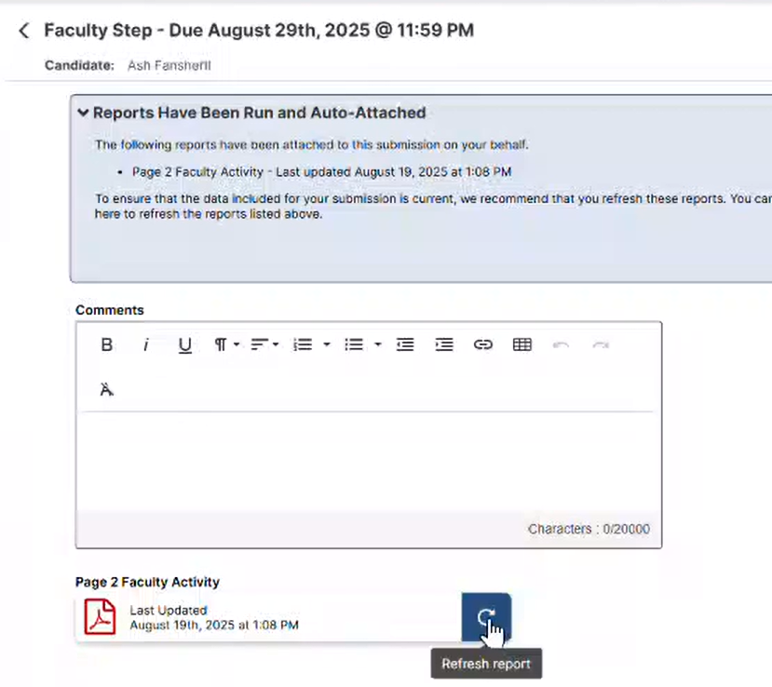

- Confirm the changes by reopening and reviewing the PDF. The timestamp on the document will also change once the refresh is complete.
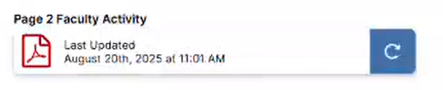
The Comments box on this screen is optional. Any information shared here will be seen by those approving your Page 2.

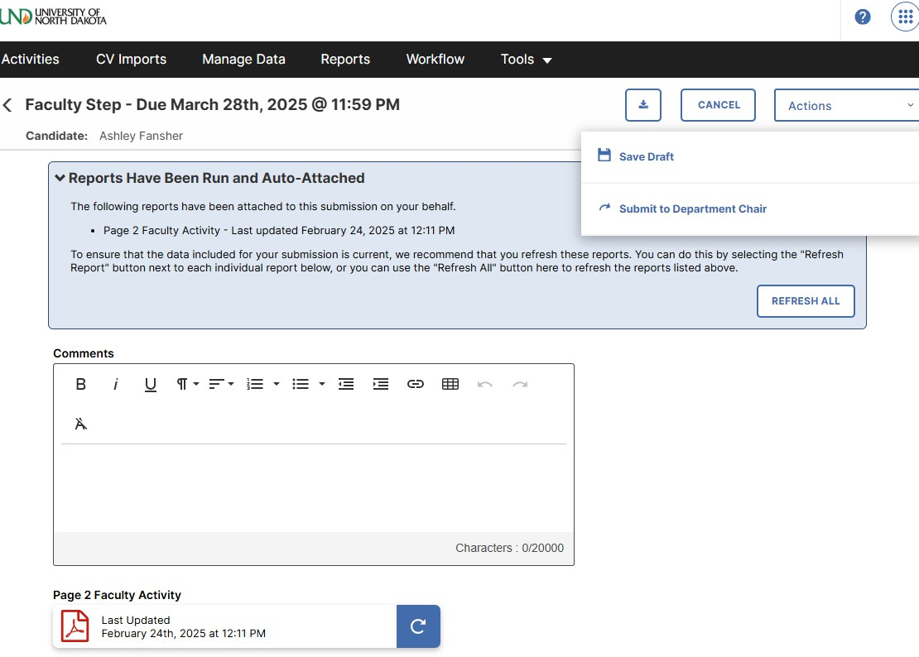
- When you are satisfied with the Page 2, go to Actions, then Submit to Department Chair.

- The chair will approve or reject the Page 2. If the chair approves the Page 2, you will not receive a notification.

To check the status of your Page 2, log into Faculty Success and click Reviews. Under Current Step, you can see where your Page 2 is in the process. “Completed” indicates that both the chair and dean have approved your Page 2.

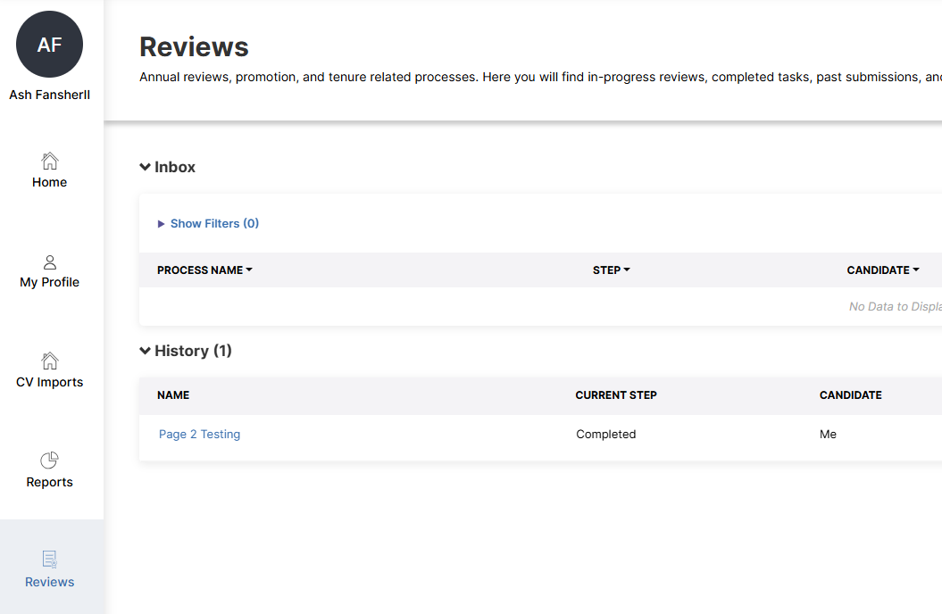

If your chair does not approve your Page 2, you will receive an email from Watermark to make changes.

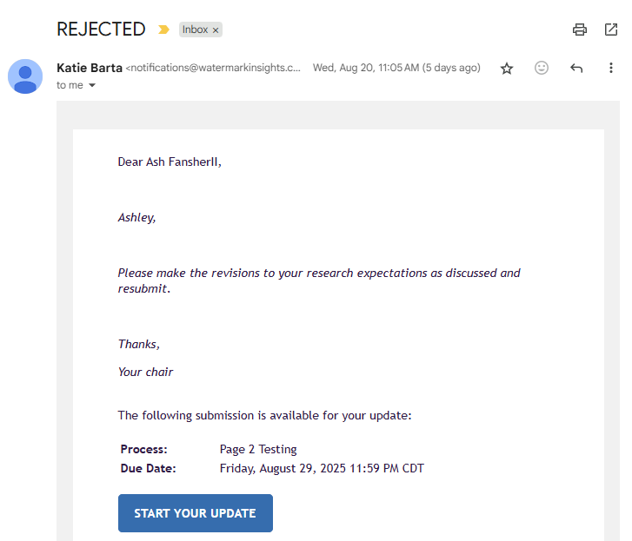

If your Page 2 is not approved, please discuss needed updates with your chair. Make changes by reentering the Page 2 through your Tasks & To-Dos. When finished, save, refresh the Page 2, review, and resubmit, using the steps above. Do not create a duplicate Page 2 during this process.

Any changes made after the approval process is complete will need a separate workflow. Please see the Page 2 – Revisions for Faculty document and video for more information on this process.

