Page 2 - Data Entry for Faculty
The following guide is for those entering Page 2 data. Additional guides will provide information regarding the approval process and revisions.
Updated: December 8, 2025
FAQS
Q: When should I start this process?
- You should talk to your chair and have your workload expectations ready before starting the online process. Our goal is to minimize passing the Page 2 back and forth after the workflow has been initiated.
Q. What is the “workflow”?
- This is the path that your Page 2 will take for approvals. Once the workflow is initiated, approvals may take place. Your chair or dean will communicate deadlines for the approval process.
Q: Where do I sign my Page 2?
- The approval process takes the place of a traditional signature. The Page 2 is part of your annual contract. You will sign off on your Page 2 expectations when you sign your full contract. There is no digital signature at this stage of the process.
Q: Can I change my Page 2?
- You may change your Page 2 as many times as you wish before the workflow is initiated. There is a separate process for revisions after approvals have been completed. Please see “Page 2 – Revisions for Faculty” for more information on this process.

- ​Log in to Faculty Success: # The University of North Dakota | Watermark
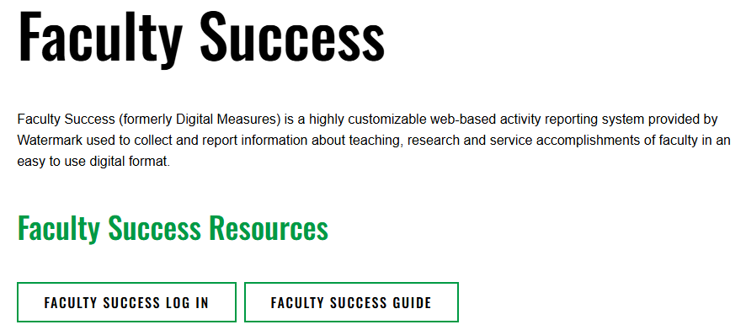
- Click on ADD ACTIVITY.
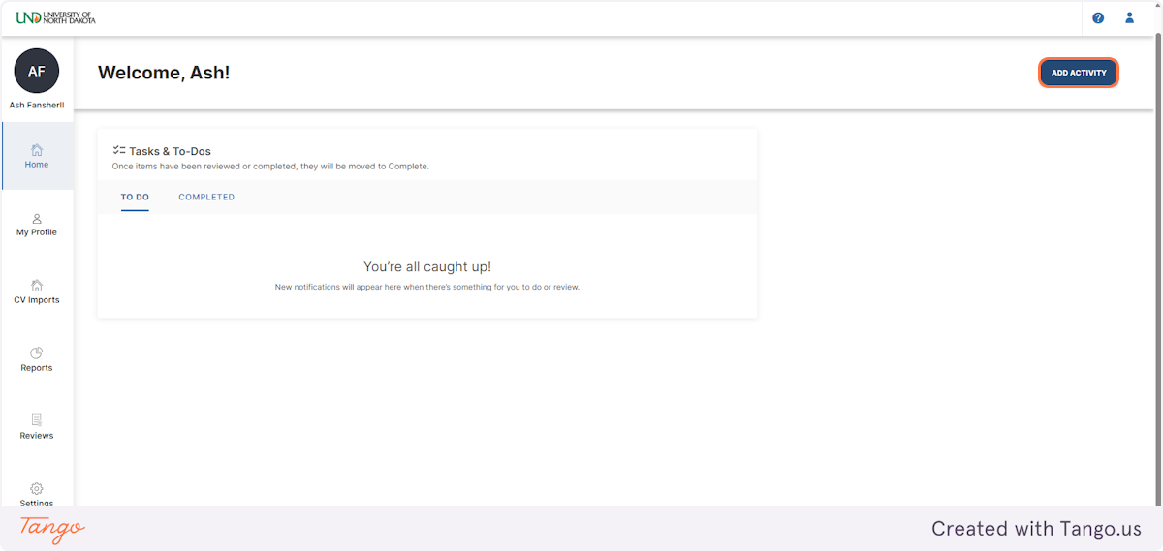
- Click on Page 2 [Future Goals].
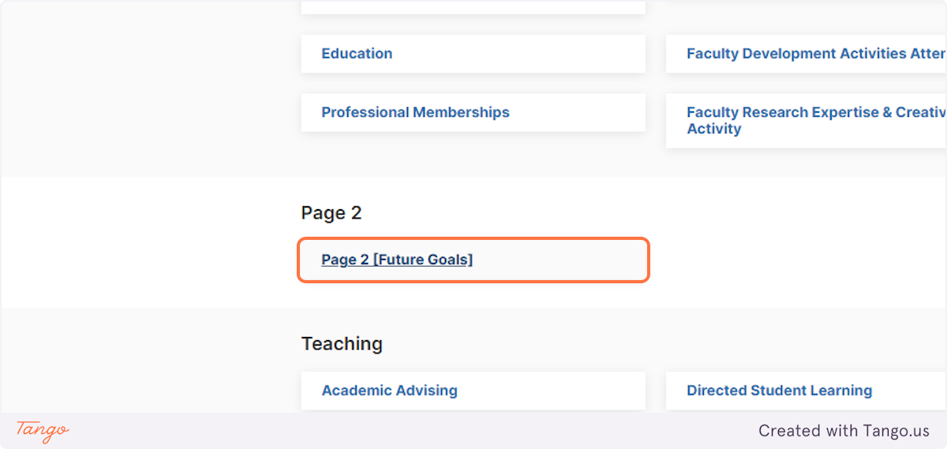

- Select ADD NEW in the top-right corner.
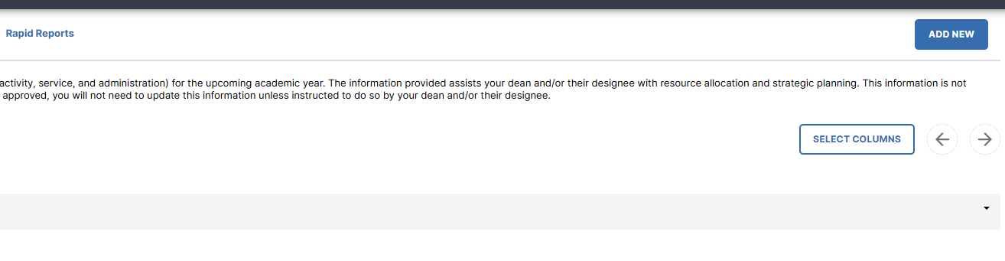
- Type the year you are preparing the Page 2 for and select, along with your contract length.
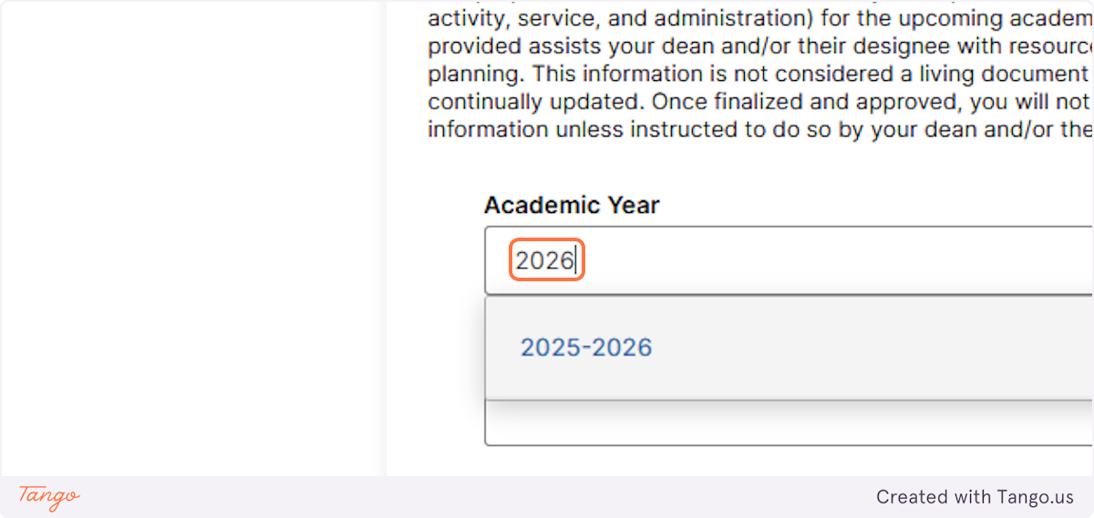
- Click on Scheduled Teaching.
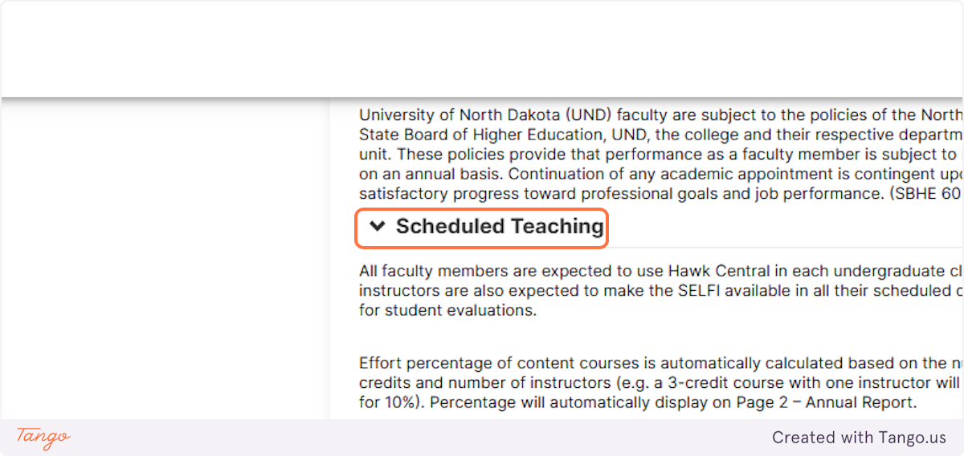
- Add the information for your scheduled classes. These should be assigned by your chair. If you do not have the full schedule, please add as much information as is available.
For example: You may not know the class name but know that it will be 3 credit hours, not co-taught, and have 1 instructor. This is the information that allows Faculty Success to calculate your teaching percentage.
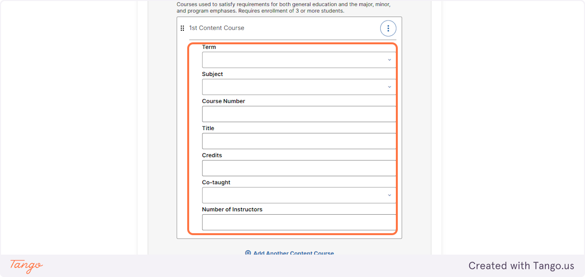
- The subject is the department abbreviation.
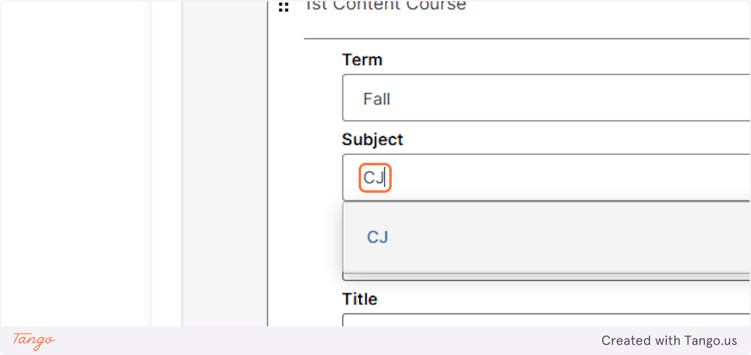

- The remaining information will need to be manually added.
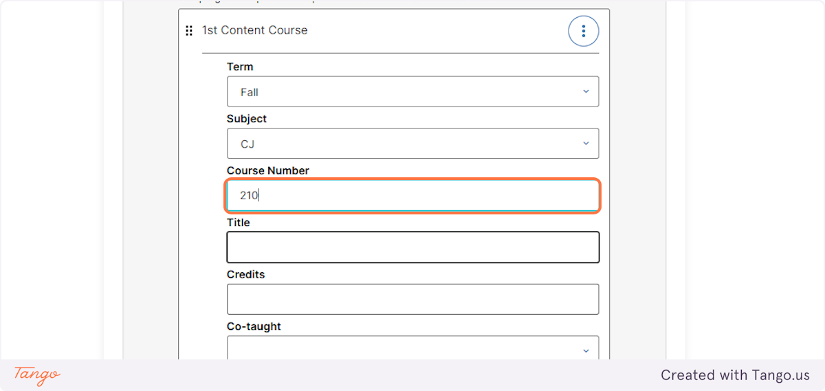
- Add the course title, if known.
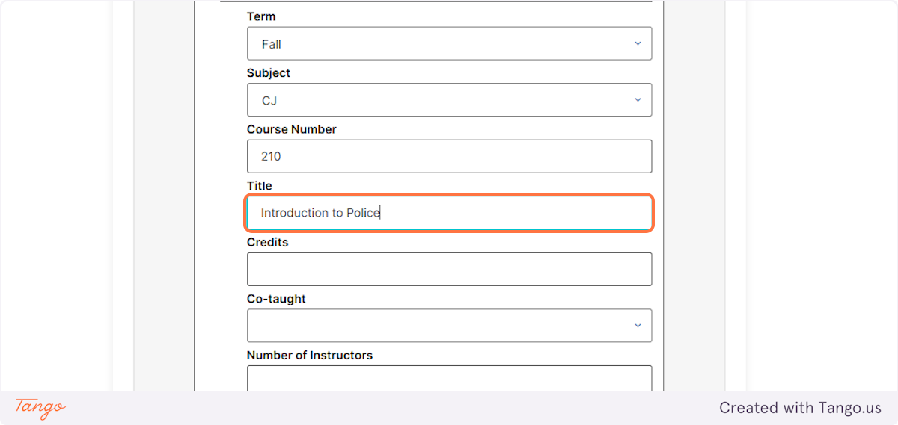

- Add the credit hours. This allows the system to calculate percentage effort for teaching (e.g. 3 credit hours = 10% effort). Percentages are calculated behind the scenes of Faculty Success.

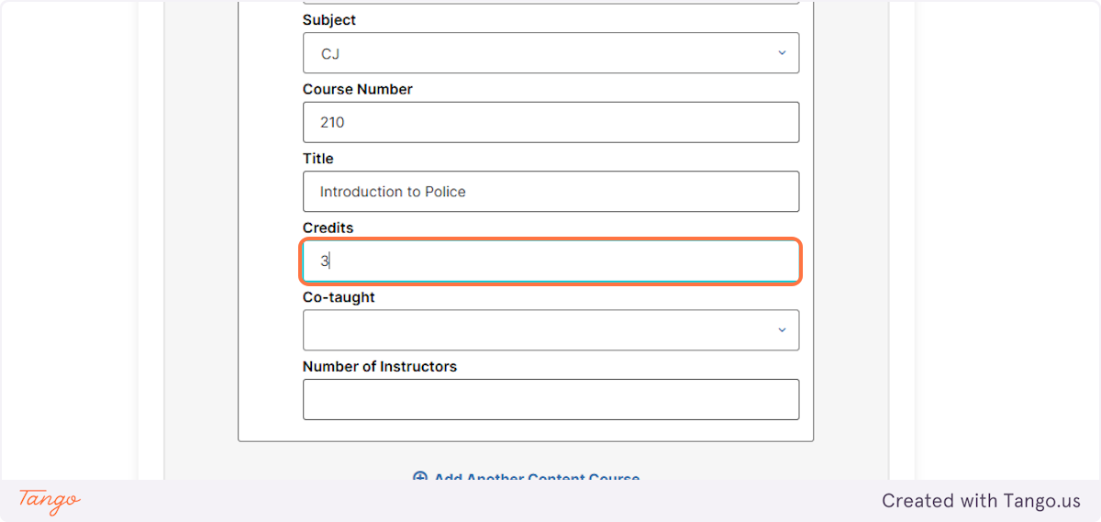
- Note if the course is co-taught and the number of instructors.
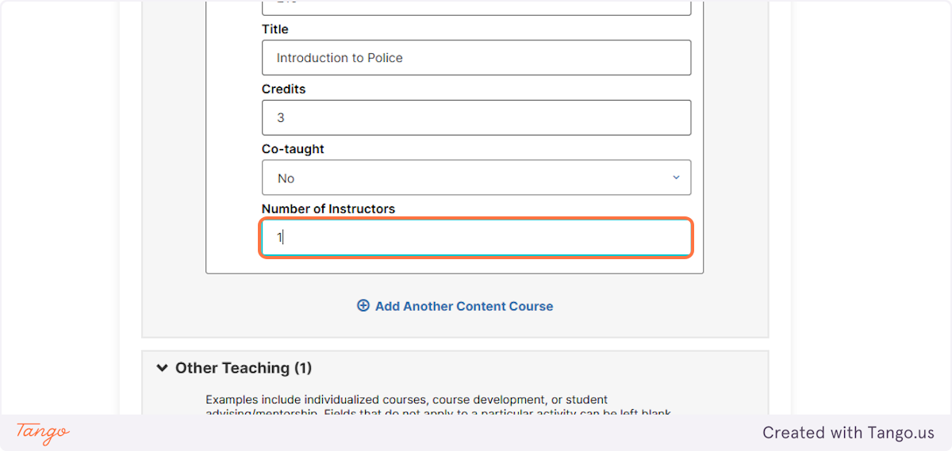

- Add additional courses as needed, using the steps from above. Your planned courses for the entire academic year should be added, with as much information as is available.

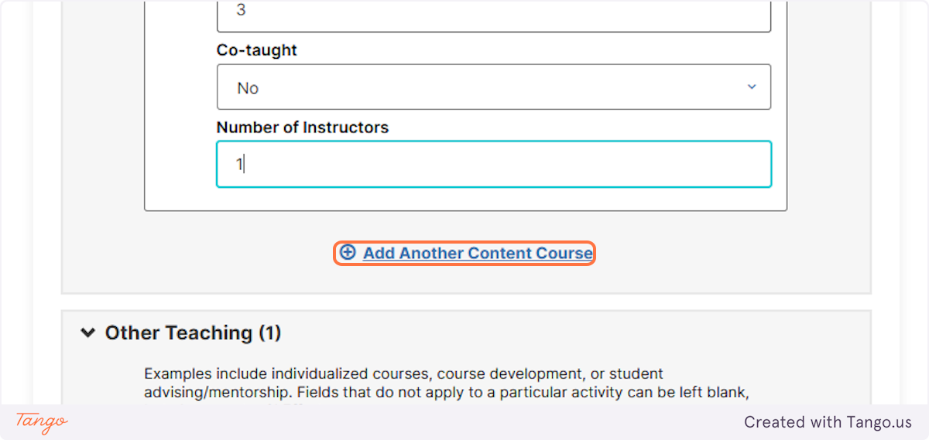
- You may also add other teaching. This should be discussed with your chair prior to completing.

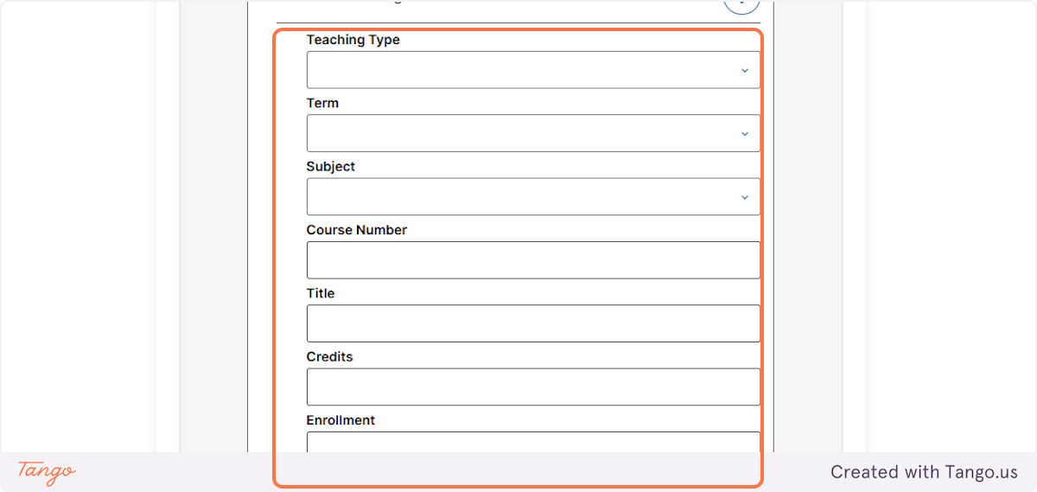

In this example of “other teaching”, I will add student advising.
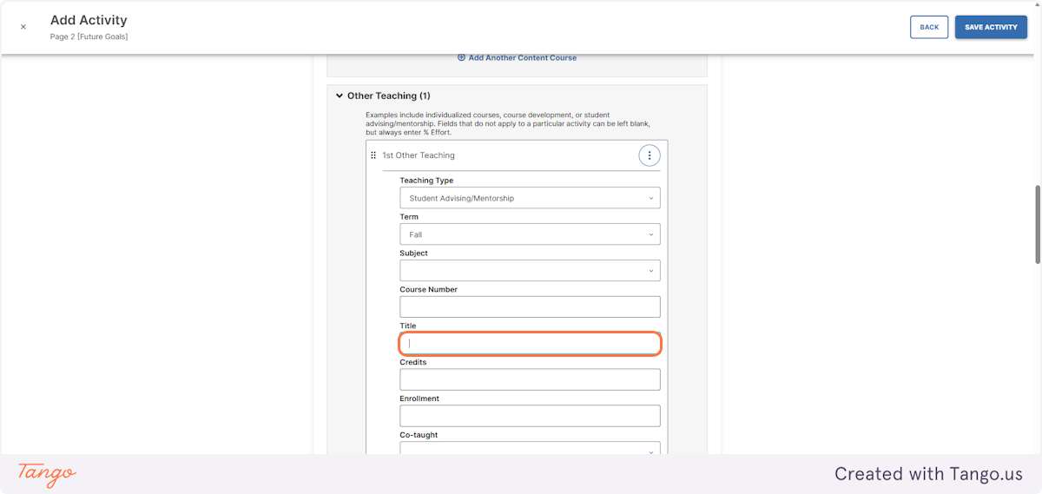
Most of the requested information is not applicable to advising and may be kept blank. The % effort will need to be added manually. If you are engaging in the activity for the entire academic year, you will need to enter the information for fall and separately for spring, with separate percentages.

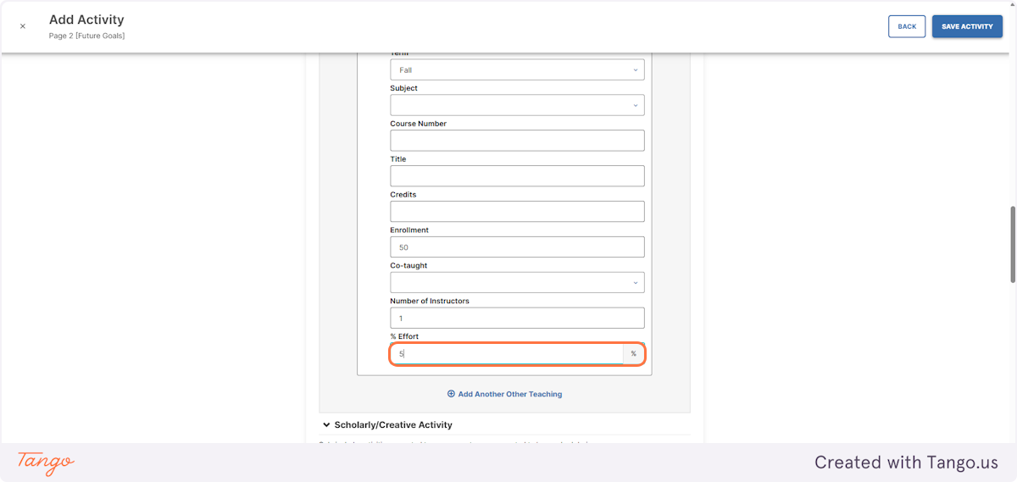
I would then enter the same information for the spring semester, with 5% effort for spring as well.

- Click on Scholarly/Creative Activity if you have this as part of your contract. If you do not have scholarly/creative activity, you may leave this blank.

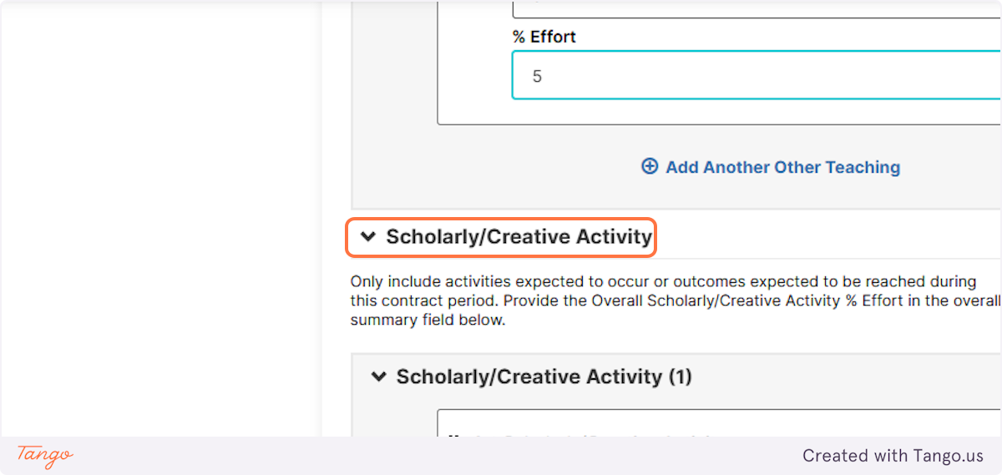
- Enter your expected activities using the appropriate drop down option. Add a brief description of the activity. Note whether the activity is extramurally funded and how much of your salary will be covered extramurally.

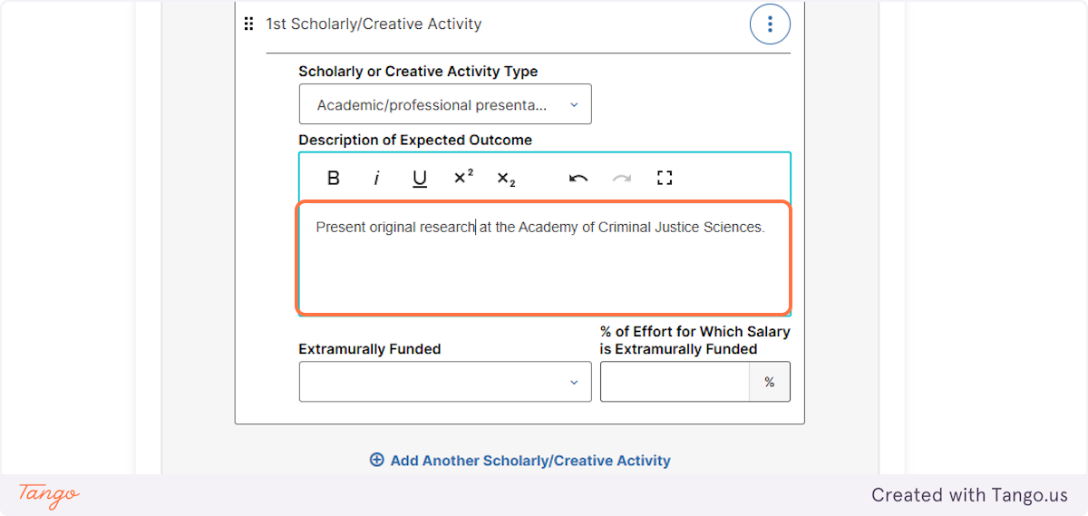

- Add as many activities as needed to complete your expectations for the upcoming academic year.

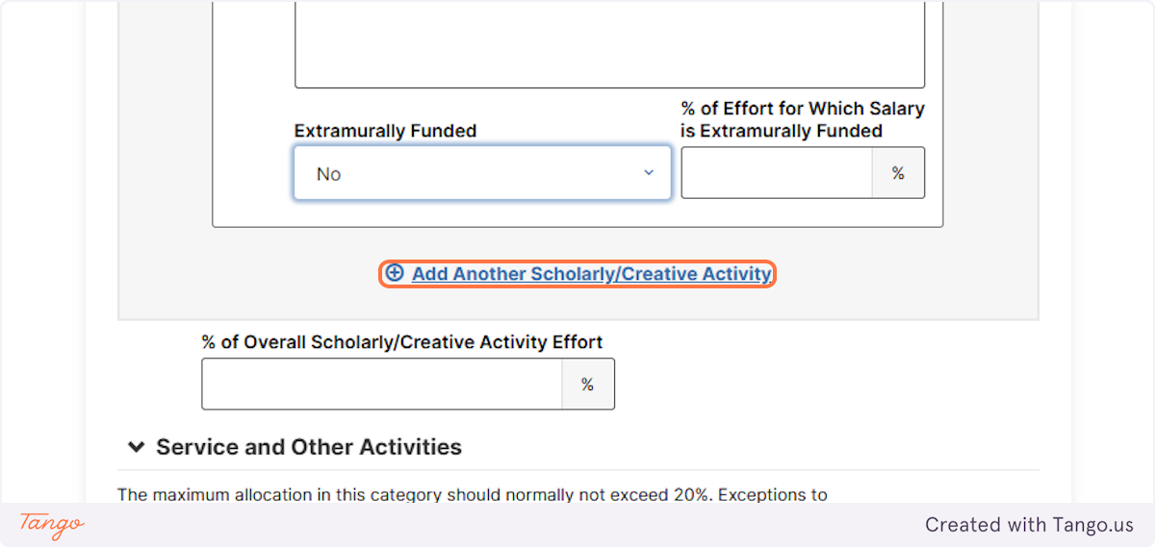
- Add your full percentage for scholarly/creative activities, as agreed upon by your department and college.

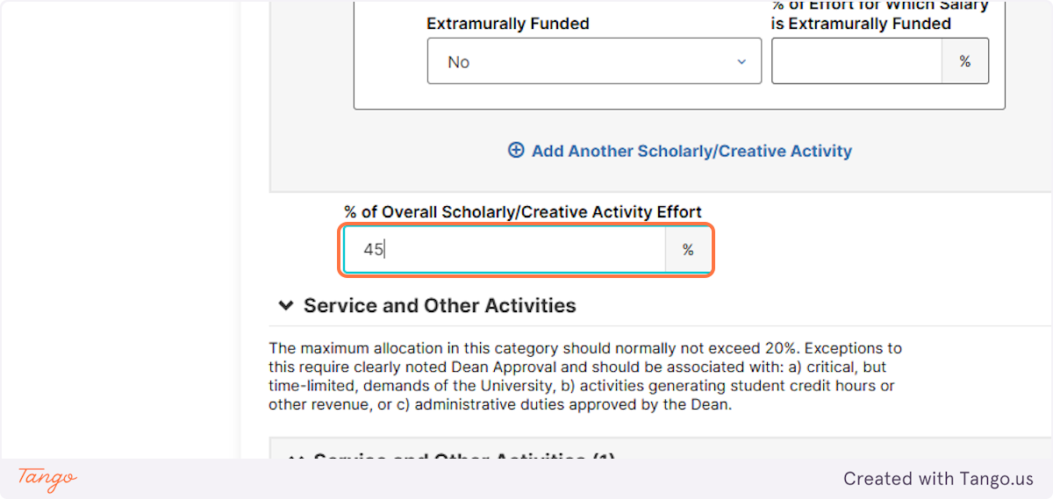

- Click on Service and Other Activities.
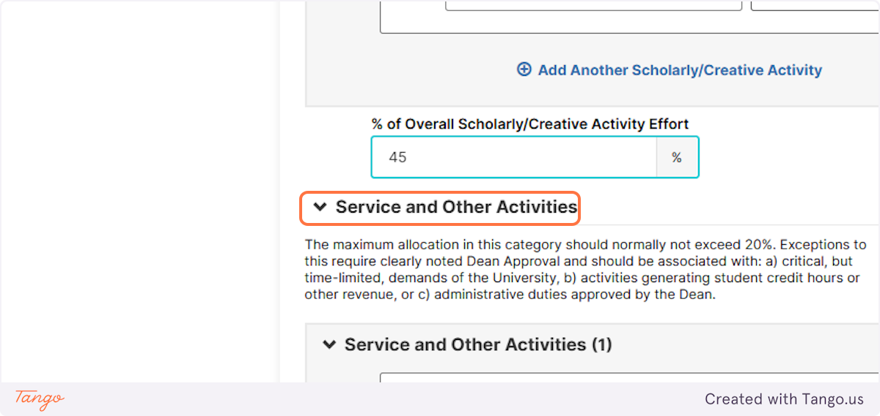
- Add your expected service activities, separated by type.
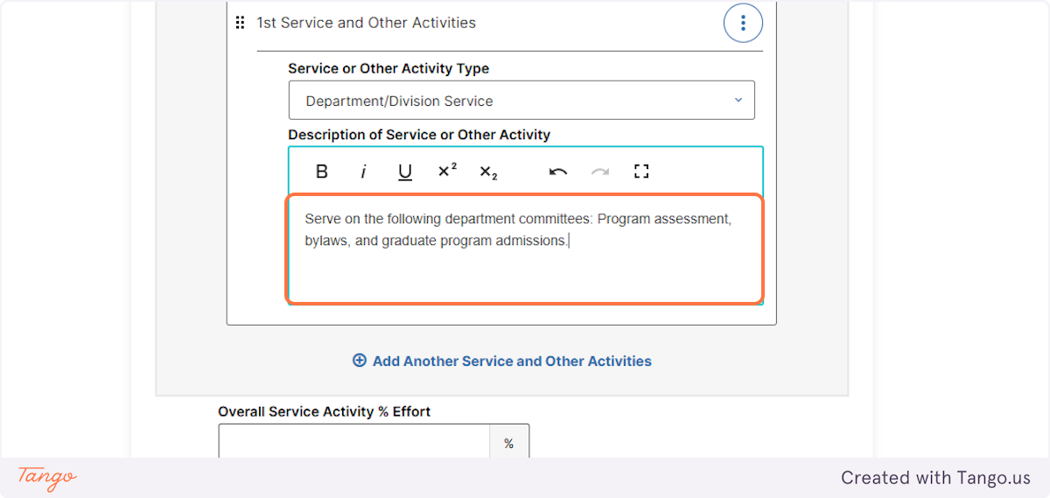

- You may add as many expected service activities as needed. Please discuss expectations with your chair.

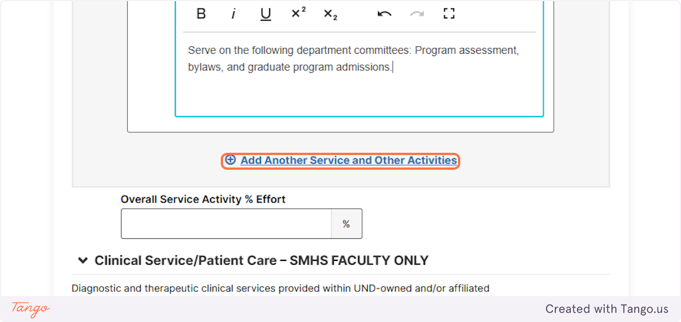
Here is a second example of a service activity.
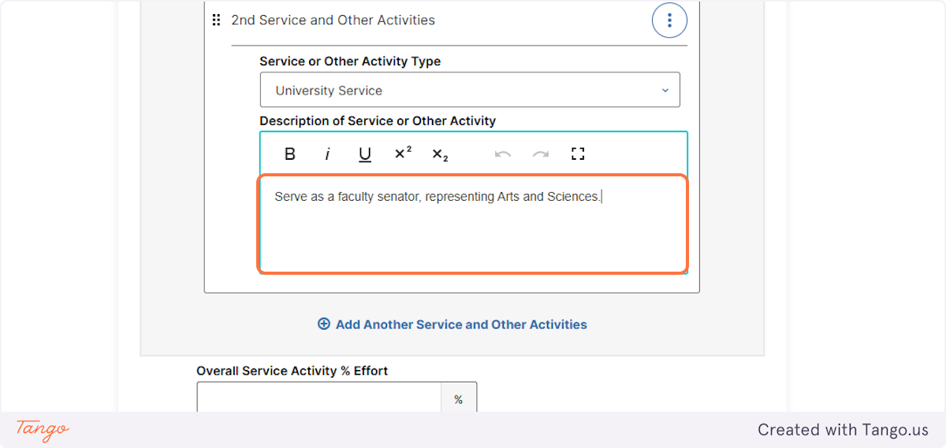

- Add your overall service percentage, as determined by your chair and college.
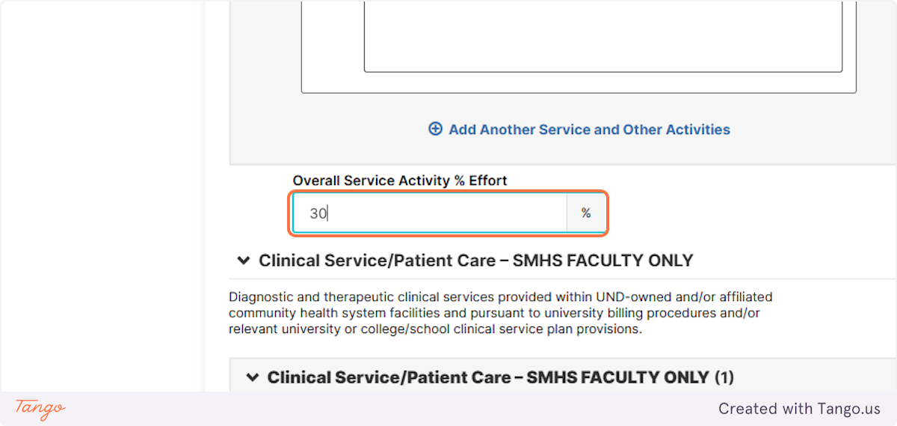
- SMHS faculty must also complete the Clinical Service/Patient Care section and note the total percent effort to expected.

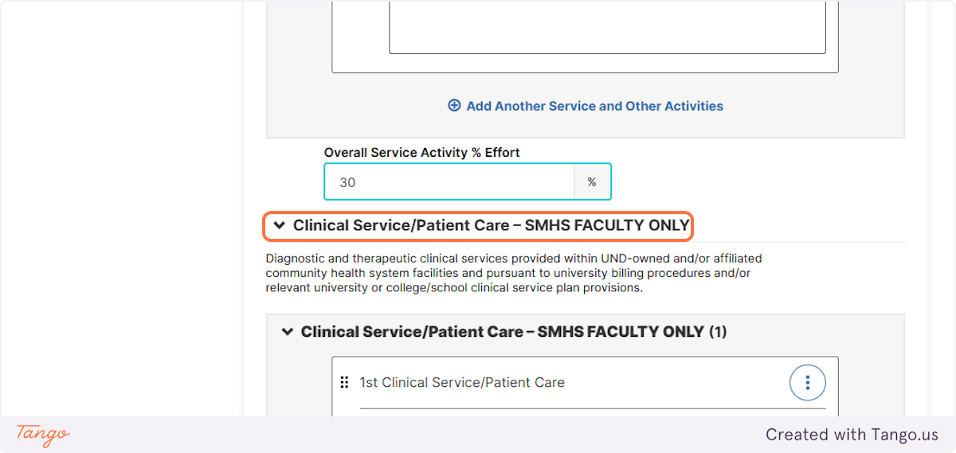

- Those with an administration role (e.g. Chair, Dean, Program Director, etc.) should also enter this information, with the expected percent effort as determined by their department, college, or the university.

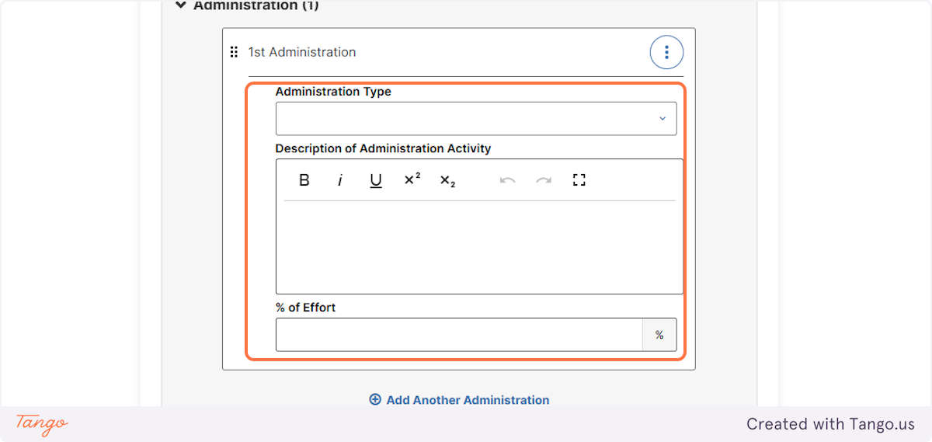
- When you are finished, click SAVE ACTIVITY.
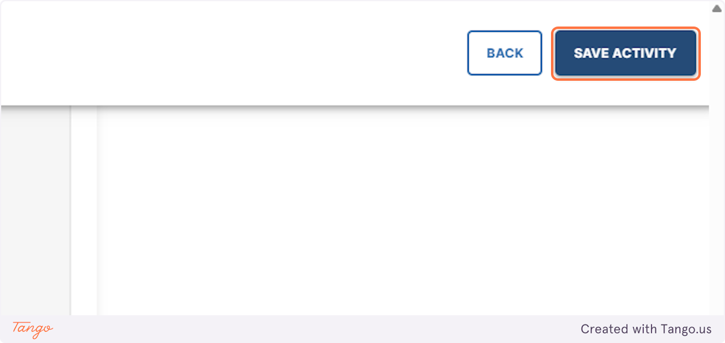

Making Revisions Before Approvals
- To re-enter your Page 2 and make edits before the workflow has been initiated, start with My Profile.

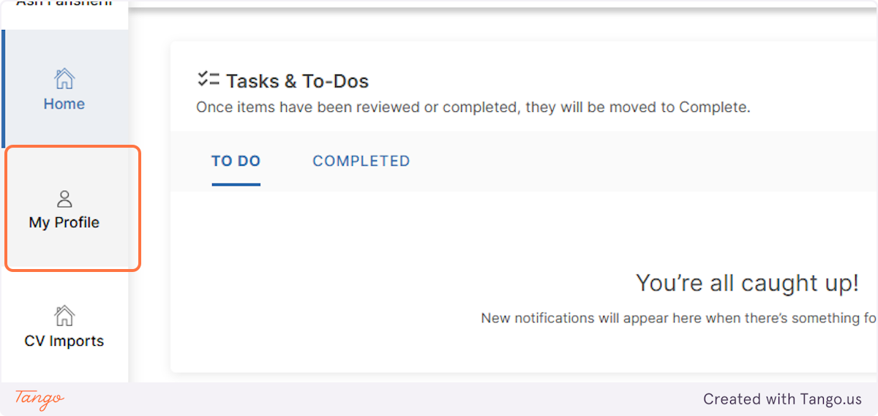
- Click on Page 2 [Future Goals].
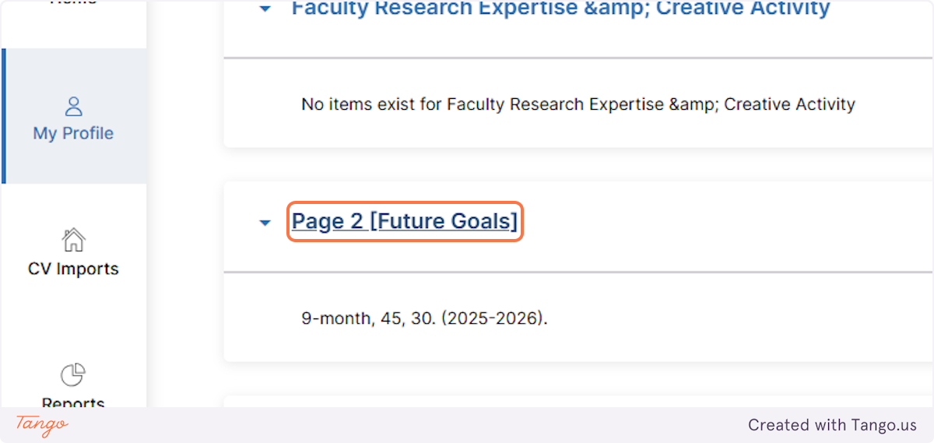

- Click on the appropriate academic year and click the small edit button on the right side of the screen. You may begin to make edits.

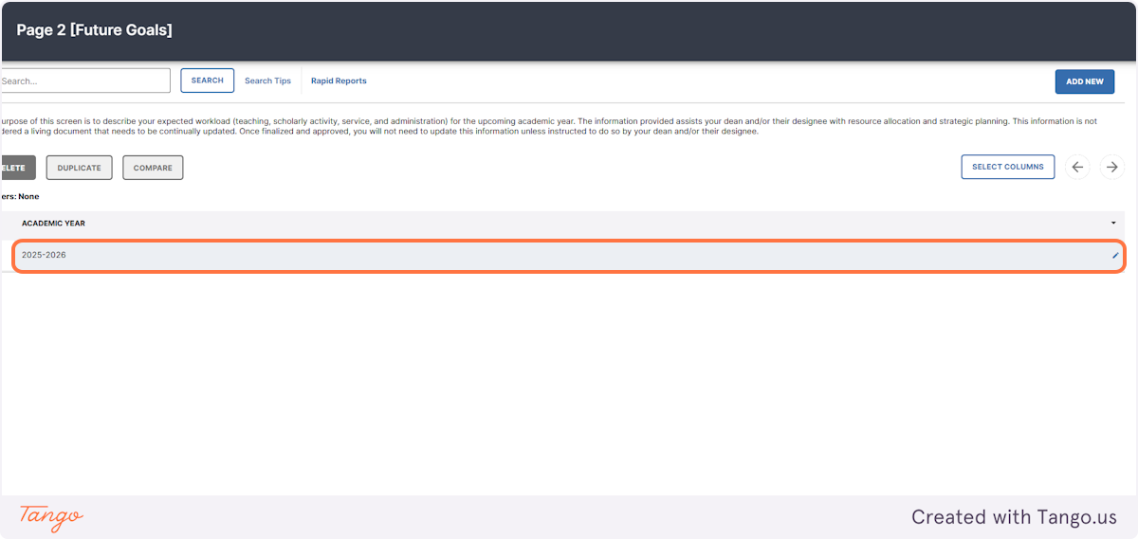
- Click on SAVE when finished.
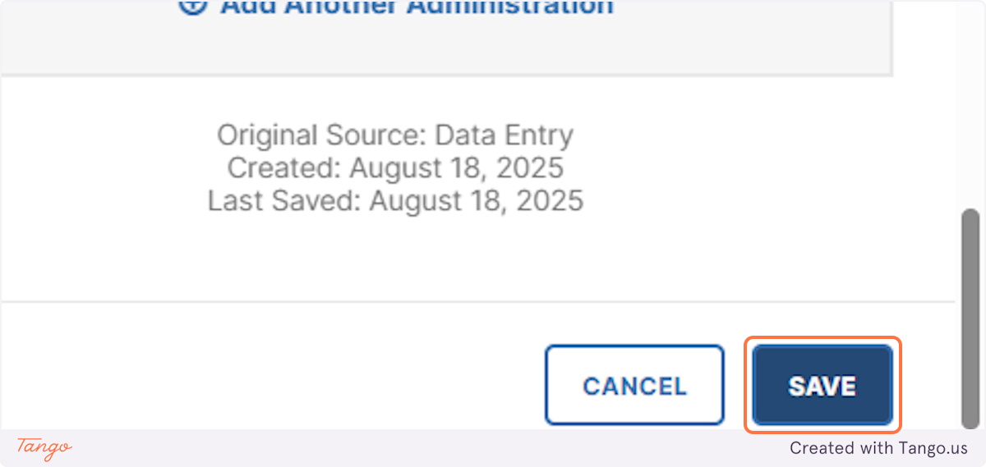

Making Revisions During the Process
If the workflow has been initiated, but you have not submitted to your chair, you may still make changes before submitting to your chair.

- Check the status of your Page 2, by clicking “Reviews” and looking at your “History.” If the Page 2 is with your chair, you may “recall” the Page 2 to make changes.

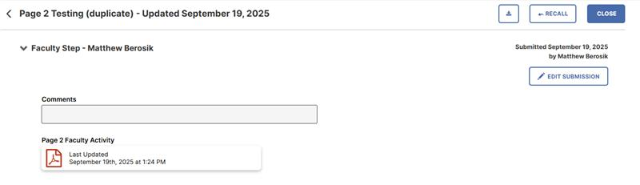

- If your Page 2 is with the dean, you will need to ask your chair to recall the document. The document may only be recalled by the role directly below where it is currently sitting.

- If the Page 2 has completed the approval process, you will need to request a revision workflow through your chair.

