Page 2 – Administrators
This guide details the Page 2 process for administrators. Separate guides are available for faculty and data entry.
Updated: January 8, 2026
FAQS
Q: When should I start this process?
- You should talk to your faculty and have workload expectations ready before starting the workflow. Our goal is to minimize passing the Page 2 back and forth after the workflow has been initiated.
Q. What is the “workflow”?
- This is the path that the Page 2 will take for approvals. Once the workflow is initiated, approvals may take place.
Q: Where do I sign the Page 2?
- The approval process takes the place of a traditional signature. The Page 2 is part of the annual contract. Faculty will sign off on their Page 2 expectations when they sign their full contract. There is no digital signature at this stage of the process. The “approval” requires signing into an authenticated NDUS account.
Q: Can I change a Page 2?
- Faculty may change their Page 2 as many times as they wish before the workflow is initiated. There is a separate process for revisions after approvals have been completed and a form is required.

The approval process begins at a date determined by the provost’s office.
- Please work with your faculty prior to the workflow initiation date to set expectations for the upcoming year. The faculty member may make unlimited changes to their Page 2 before the approval workflow is initiated.

Once the workflow is initiated, faculty will receive an email to their UND email address. The email will be coming from Watermark. Alternatively, they can access the approval process by logging into Faculty Success and viewing their “Home” page.

- After the workflow is initiated, faculty may begin submitting their Page 2 to their chair. The traditional workflow will go from faculty to chair to dean. Alternative workflows will be discussed below.

- The chair will receive an email from Watermark Faculty Success when a faculty member has submitted their Page 2 for review.

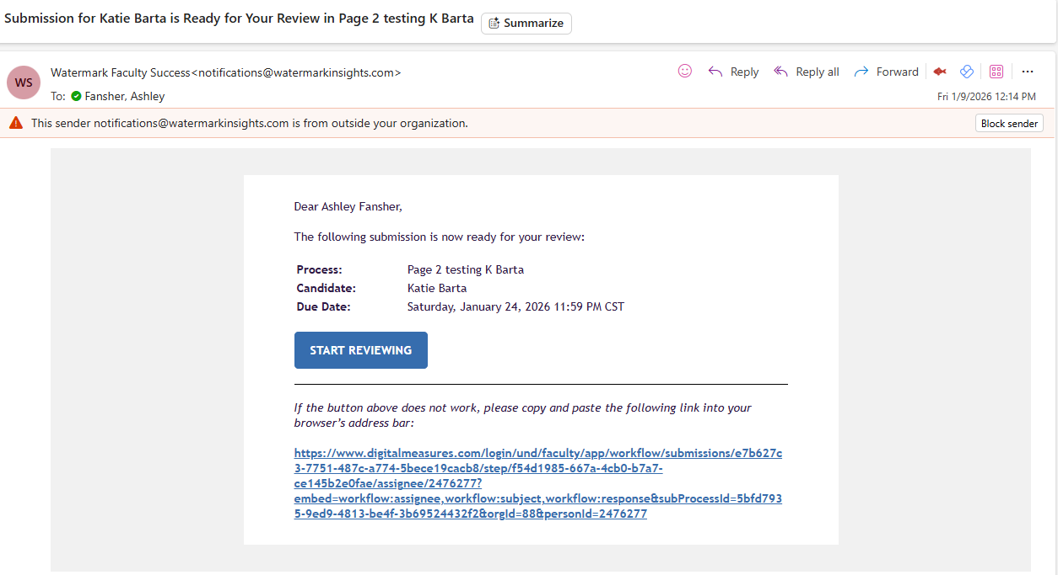
To view all of your faculty submissions at one time, log in to Faculty Success. Navigate to “Workflow” and “Tasks.” This will show all pending Page 2s and where they are in the approval process.

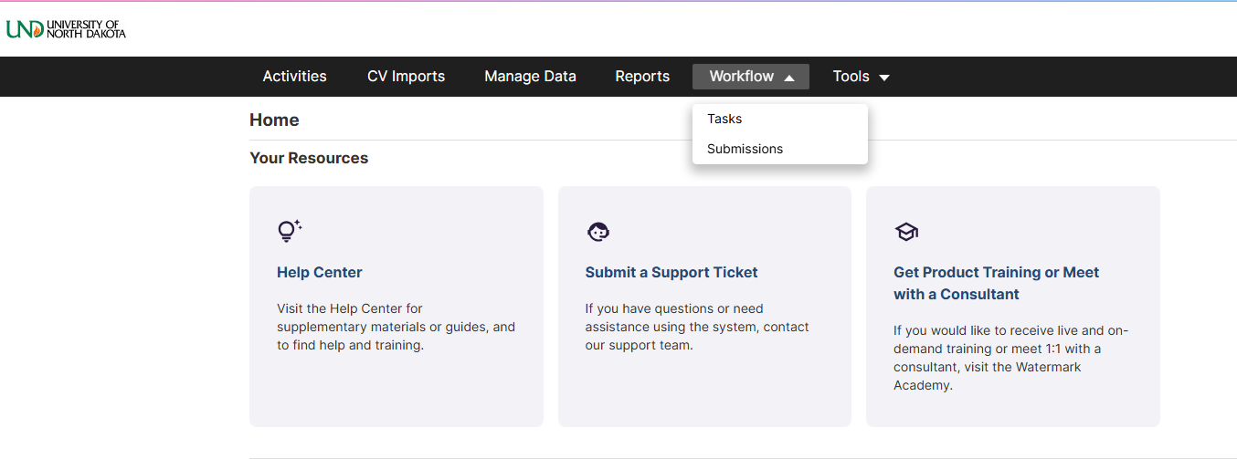

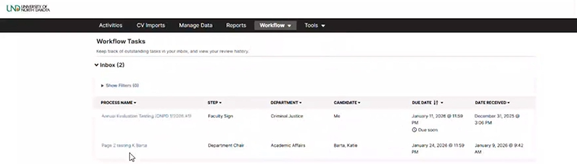
- Click the faculty member to review their submission. You may download the submission or open the file by clicking the PDF icon.
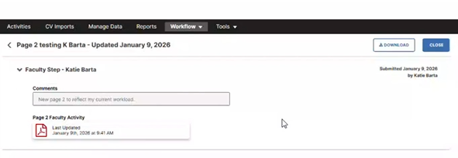

- Review the submission, confirming that the final total percent effort equals 100%. The total percent effort will be automatically calculated for Content Courses (e.g. 3 credits = 10%) and overall Teaching expectations. Faculty will need to manually enter percentages for Scholarly/Creative Activity and Service.

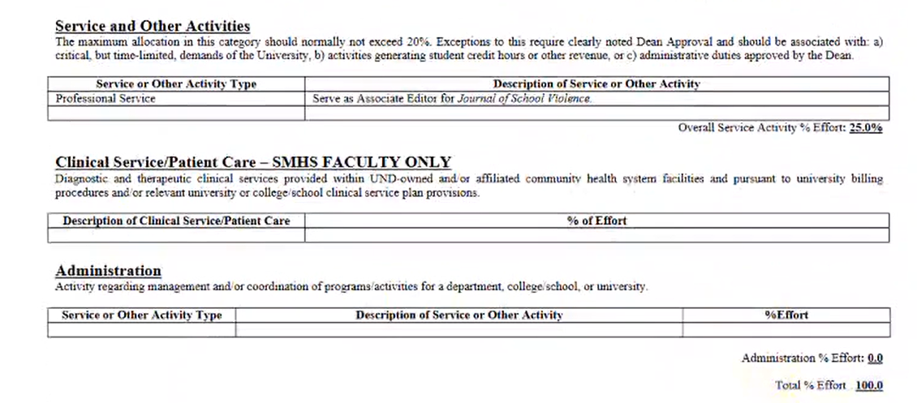
To get out of the PDF, click back on “Workflow” and “Tasks.”

- You have two options after reviewing the Page 2.

You may accept the Page 2 as is and submit it to the Dean for final approval.

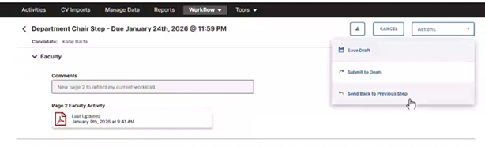
If changes need to be made, you may send the Page 2 back to the faculty for edits by clicking “Send Back to Previous Step.”

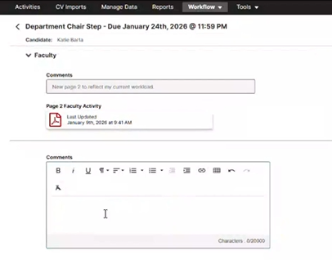

Note: The comments box here is optional. Any comments here will be seen by the Dean.
If you opt to send the Page 2 back to the faculty member for revisions, you will be prompted to include a message with the rejection.

If sending back to the previous step, Watermark will open an email message window.

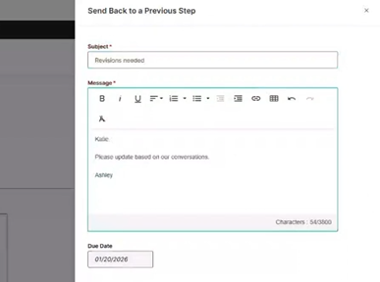

This may be as minimal or detailed as you prefer. Any message typed here will not remain attached to the Page 2.

The faculty member will receive an email from Watermark, including your message, prompting them to revise their Page 2.

You may track where Page 2s are in the process by navigating to “Workflow,” “Tasks,” and looking under “History.”

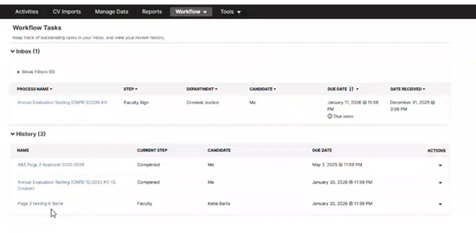
You will receive an email after the faculty member has resubmitted their Page 2.
- Once a Page 2 has been submitted to the Dean, they have two options. The first option is to approve the Page 2, completing the workflow. The second option is to return the Page 2 to the department chair. A dean may not return a Page 2 directly back to the faculty member. If a Page 2 is returned by a dean, the chair will need to send it back to the faculty member for revisions. It then progresses back through the workflow.

- Once the Page 2 has been fully approved, you may download the final file and the approvals by navigating to “Workflow” and “Submissions.” Toggle-off the “Open” filter to view all completed submissions.
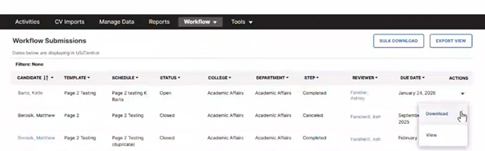

The downloaded file will include a PDF of the Page 2 and an .html file with the approvals.

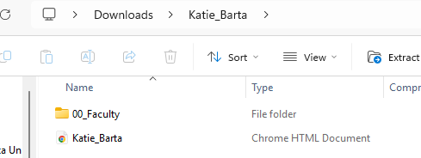

You may “print” a PDF of the approvals if you would like, but they do remain in the system.

Page 2 Revisions
Once a Page 2 has completed the workflow and is approved by the dean, any changes will need to go through a separate workflow and approval process. Workflow requests may be submitted by chairs or deans only. Please consult with your dean’s office to determine their preferences.
Revision workflows may be requested by completing the “Workflow or Revisions Template” available on the UAP Faculty Success webpage.

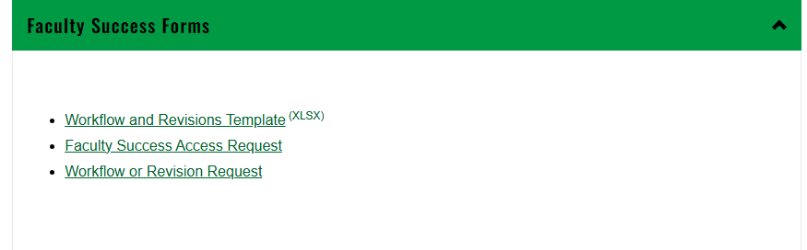

The first sheet of the form includes instructions only.
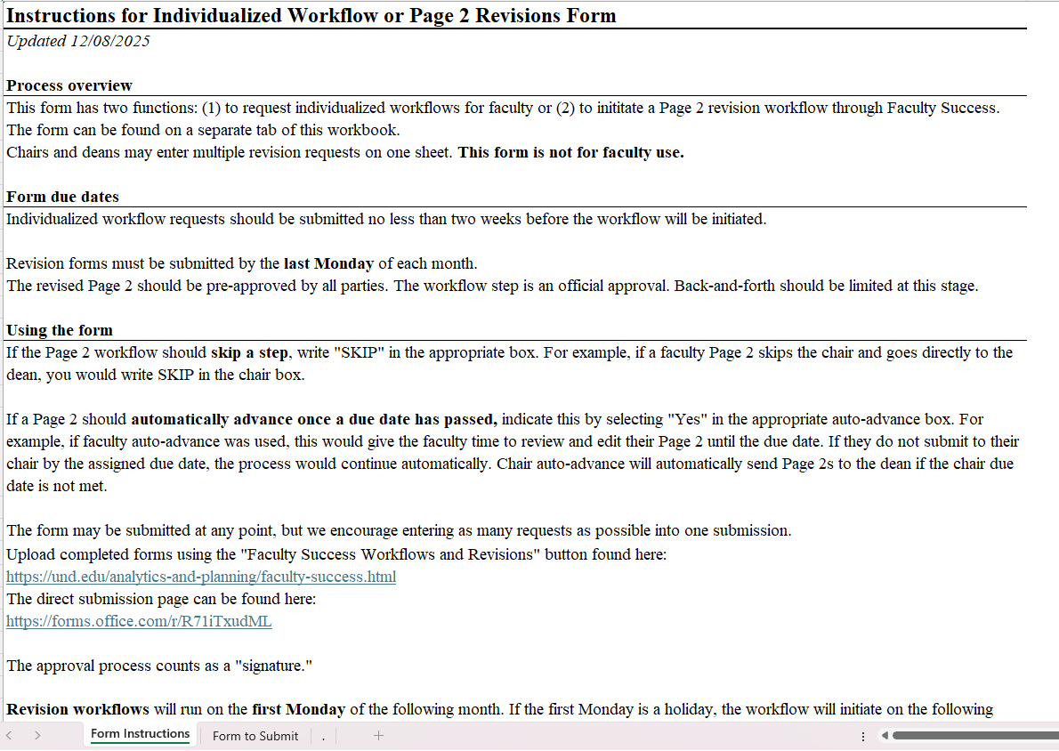

The second sheet is a fillable worksheet for revisions. You may submit as many revision workflow requests as needed on the same form.

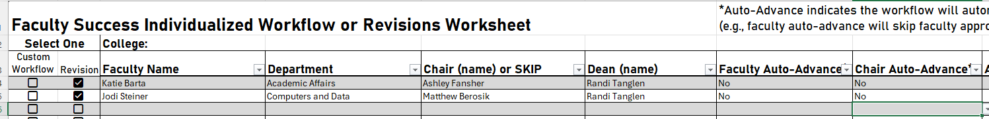

Once the form is ready for submission, save a copy, and submit under “Workflow or Revision Request.”

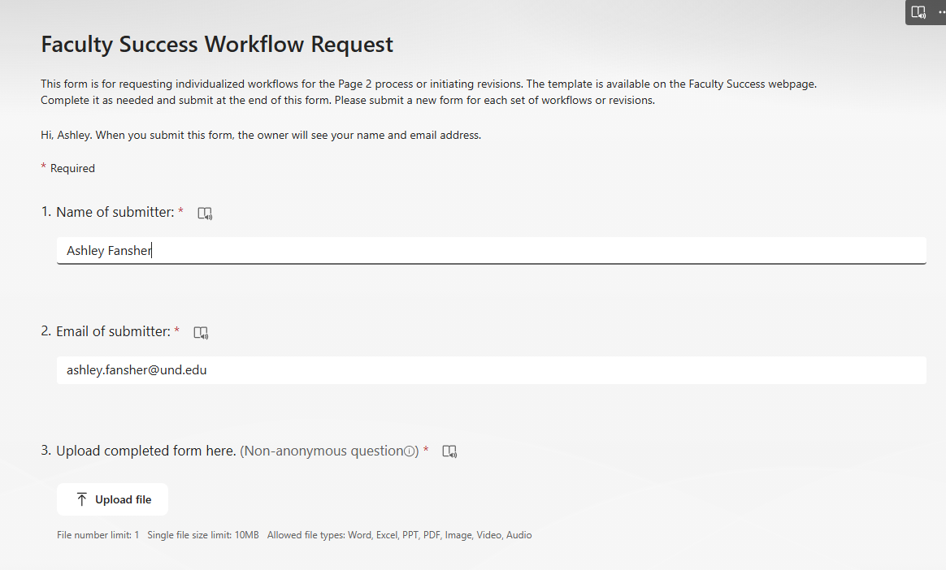

Revision requests must be submitted by the last Monday of the month to initiate workflows on the following Monday (barring a holiday).

Running Reports
The ability to view Page 2s and access reports is automatically granted to deans, for their college, or chairs, for their department. Any additional individuals who need access to view and print reports will require an access request, which will be covered below.

To print Page 2s for your entire college or department, navigate to “Reports,” then scroll to “Page 2 Annual Report.”

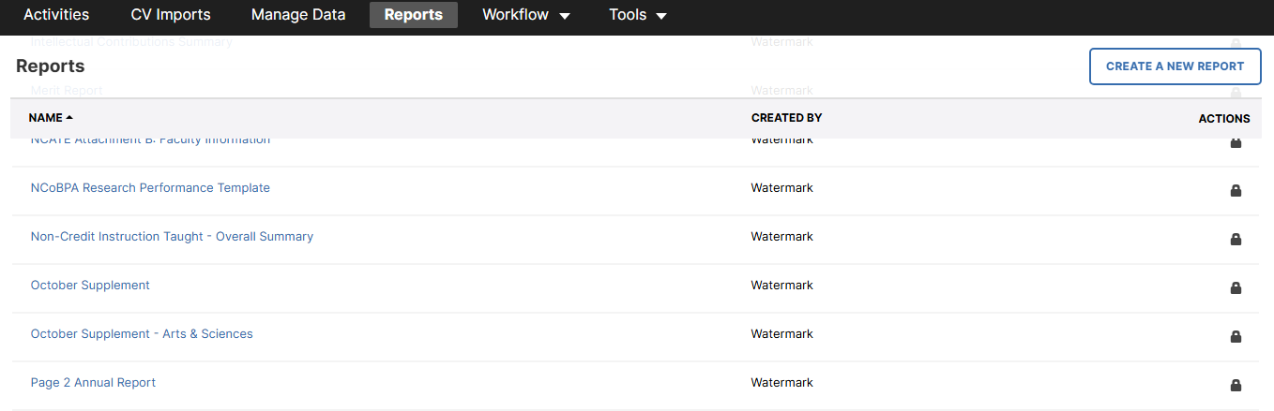

Enter the date range for which the Page 2 applies. This should be based on contract dates.

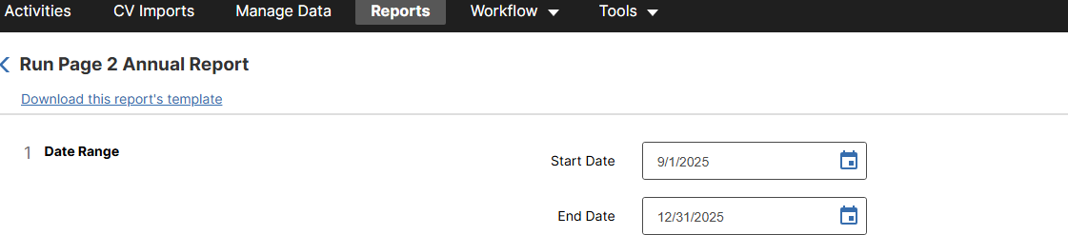

You may run the reports for your entire college (deans only) or department.

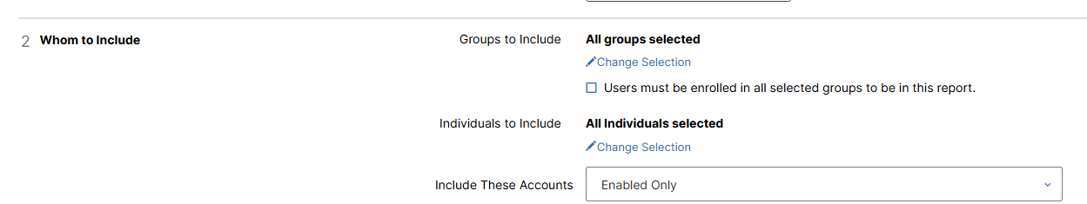

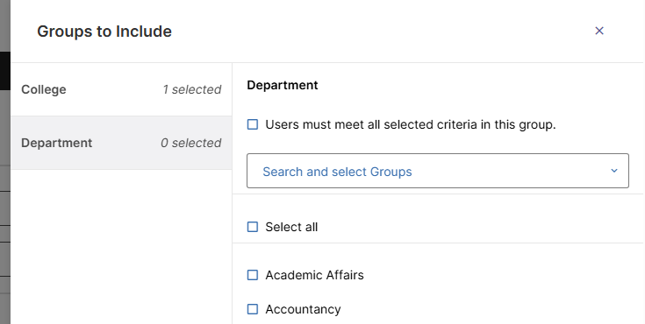

You may also run reports for specific individuals.

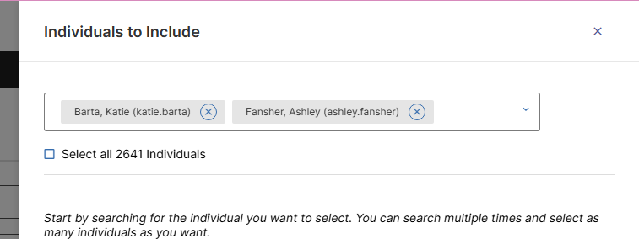

Lastly, you may run the report as a Word document or PDF. When you are ready, click “Run
Report.” A file will be downloaded for your viewing.

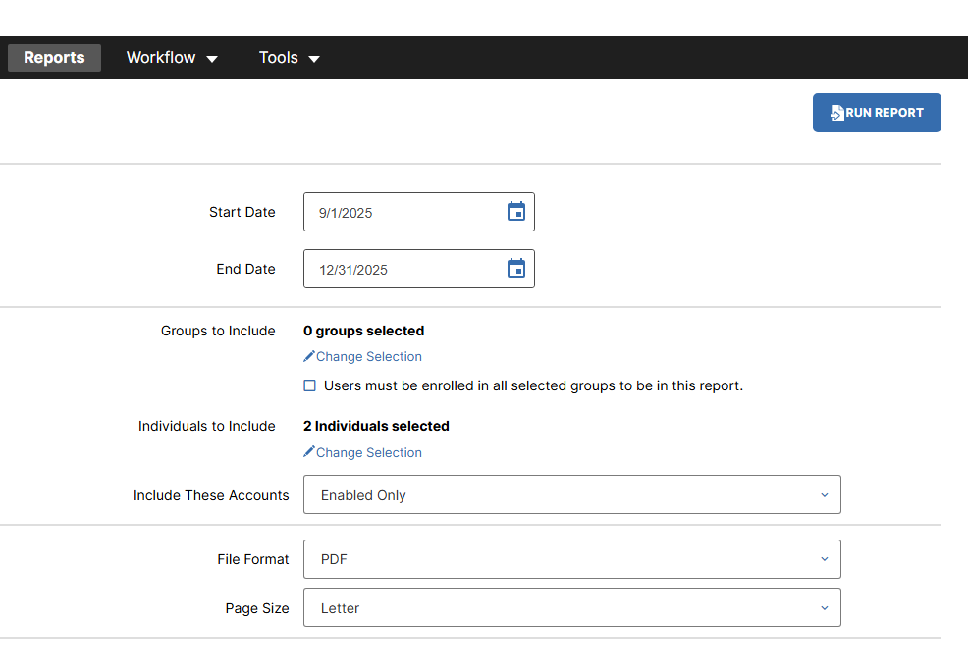
This file will only include the Page 2s. To view approval stamps, you will need to navigate to your individual faculty through “Workflow” and “Submissions,” as shown above.

Requesting Additional Access
Deans and chairs will automatically be granted access to view and print reports for Page 2s in their respective colleges and departments. To grant access to Page 2s for associate deans, assistant or associate chairs, or administrative assistants, navigate to Tutorials and Forms for Faculty Success.
Click “Faculty Success Access Request.”
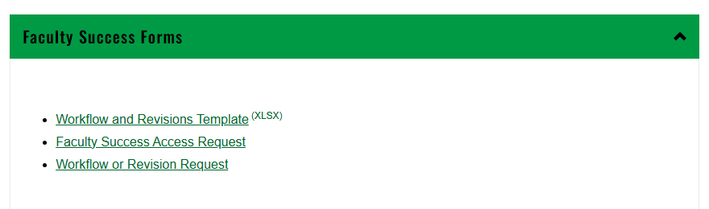

Complete and submit the short form.

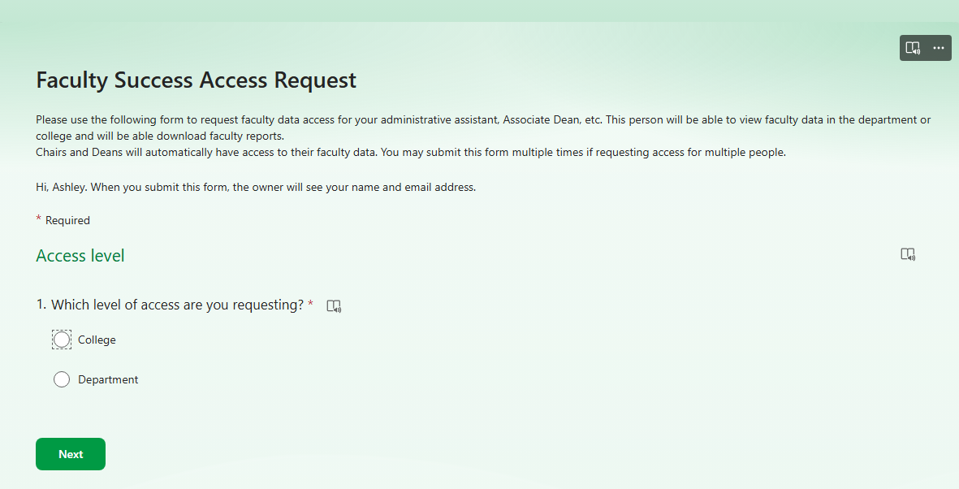

Individualized Workflows
The standard Page 2 workflow will be: faculty → chair → dean. If a faculty member needs to skip their chair, an individualized workflow request must be submitted. This is done using the “Workflow and Revisions Template” covered above. Instructions can be found on the first sheet of the template.
In the example below, a request is being made for the Page 2 to move directly from the faculty to the dean.

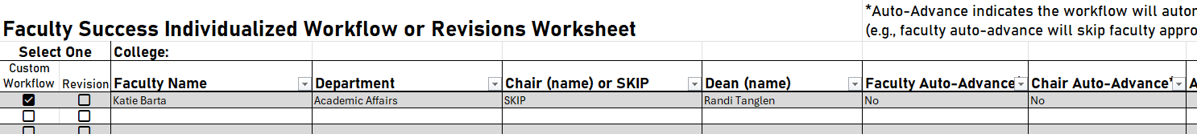

You may submit as many individualized workflows on the worksheet as needed. Once you have finished the worksheet, save a copy, and upload to the “Workflow or Revision Request” form, found on the UAP Faculty Success webpage.

