Research Imports – Google Scholar
This guide provides instructions for importing research citations for Google Scholar into your Faculty Success profile.
Updated: July 22, 2026

If you do not have a linked Google Scholar profile, you can quickly set this up HERE.
Part 1: Gather your publication information from Google Scholar.
- Navigate to scholar.google.com.
- Log in to your profile by clicking the symbol in the top-right corner.
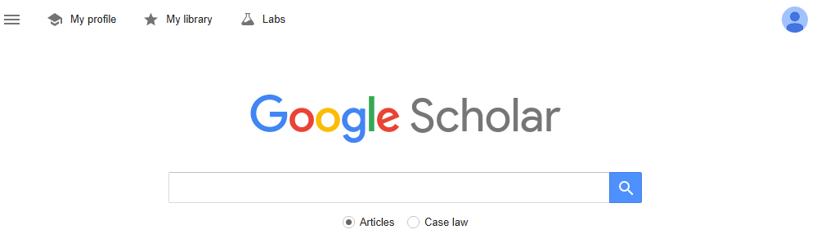

- Once logged in, click “My profile” in the top-left corner.

- Select the articles you would like to import into Faculty Success by clicking the checkbox next to the article titles. To sort articles by year, click “YEAR” once.

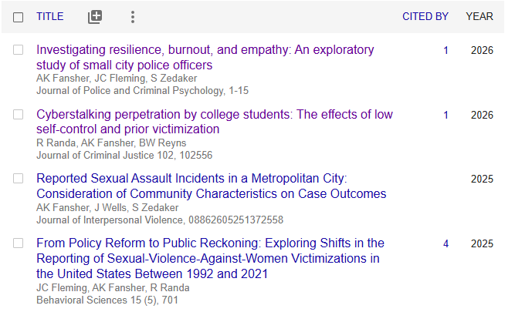

- Once your articles are selected, click “EXPORT” and then select “BibTeX.”

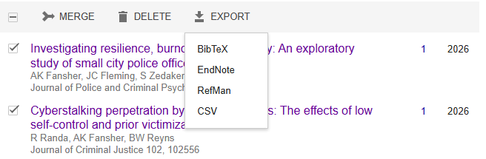
- A separate window will open with the export information. Leave this window open.

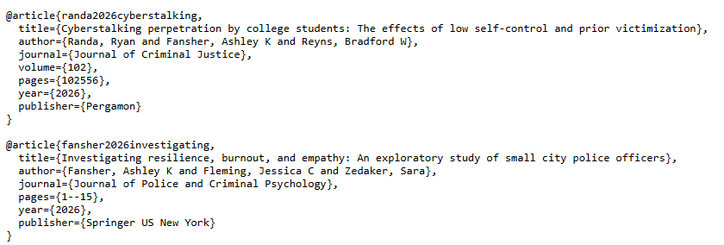
- Open the Notepad application on your computer. This is separate from your internet browser. It can be found by typing “Notepad” into your taskbar search, which is typically located next to the Windows icon.

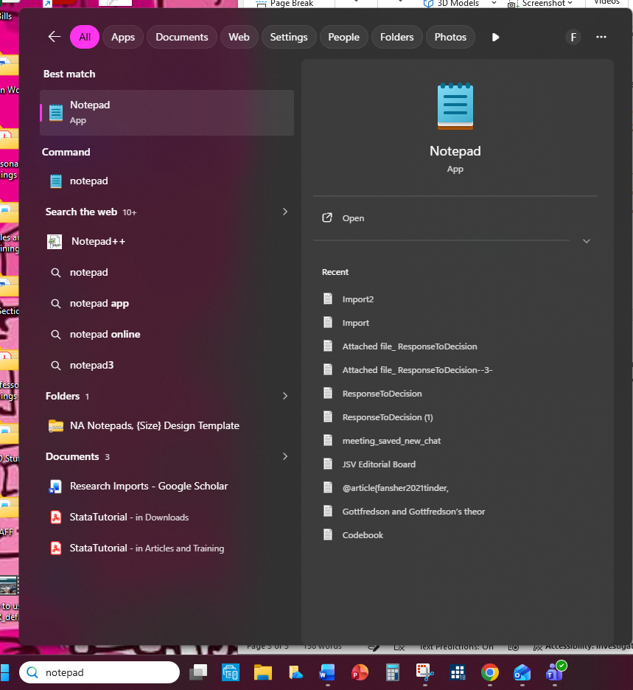

- Go back to your web browser, copy the Google Scholar information, and paste into the Notepad.

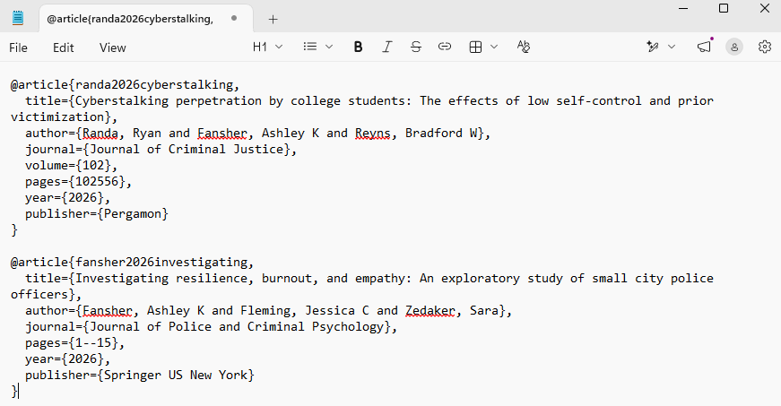
- Save this document on your computer. When you are finished, you may close the Notepad.

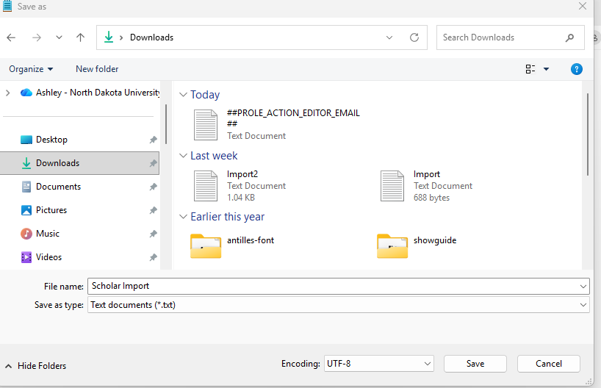

Part 2: Import the information into Faculty Success.

- Log in to your Faculty Success Profile.

- Go to “My Profile” and scroll to “Intellectual Contributions.”

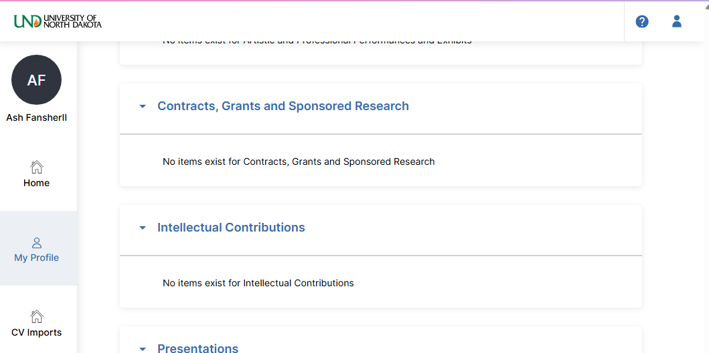

- Select “Import” in the top right corner.

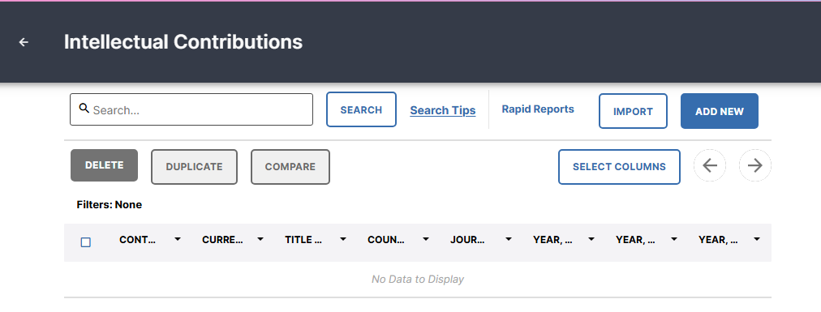
- Under “Import from a BibTeX file,” select “Choose File…” If you would like to import from ORCID or PubMed, please refer to the separate guide.

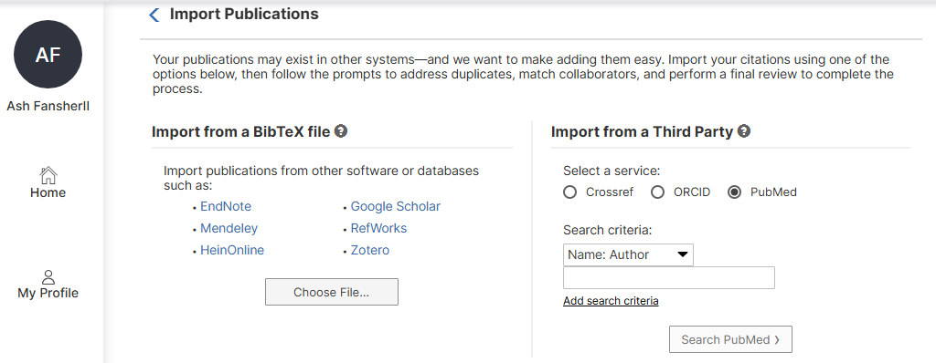
- Select the Notepad file with your Google Scholar information.

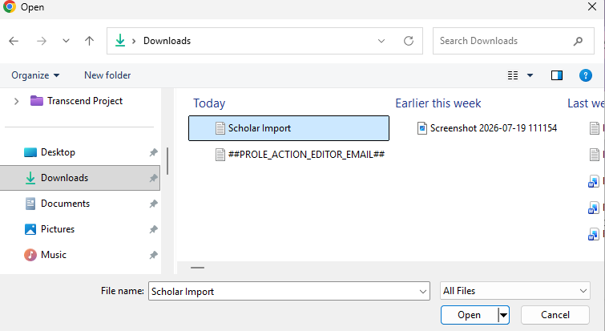
- You will be prompted to link publications to other co-authors who work at University of North Dakota. The screen will list the co-authors for all publications that are being imported. If you would like to link a publication to a UND employee, select “Match to a user account” and locate the co-author.

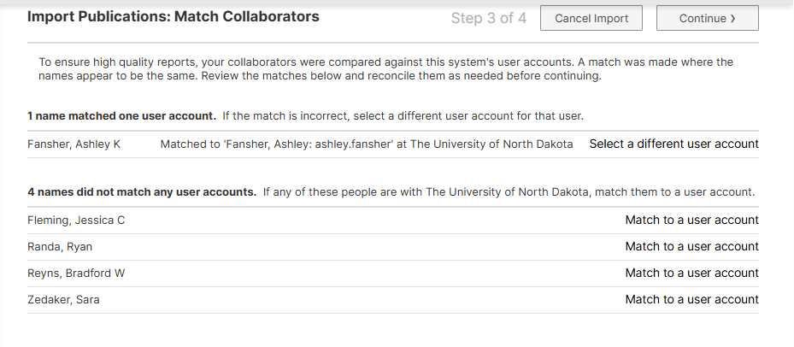
Note: Linking a publication to a UND co-author will populate the publication on their profile as well. They may delete the addition if they do want it to appear. It is not required to link co-authors. If you skip this step, the other authors may enter the information on their own.

When you are done linking co-authors, or if you have no co-authors to link, select “Continue.”

- You will be asked to review the information being imported. This screen does not allow you to edit the entry. Review the information, making a note of any information you would like to edit. Click the arrows to review each publication.

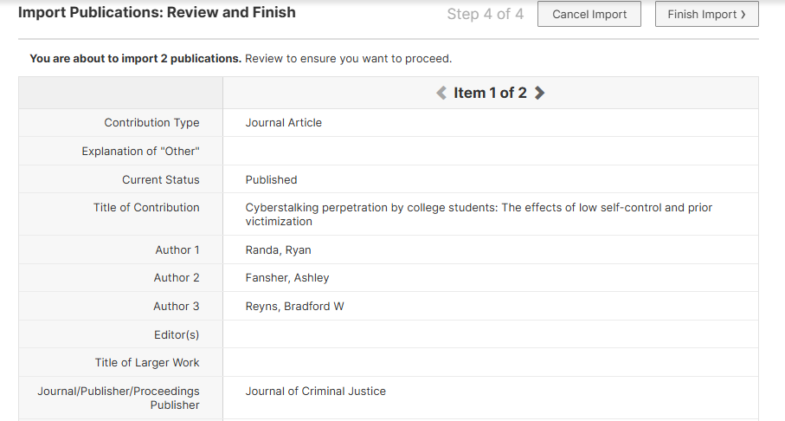

- When you are finished reviewing, select “Finish Import.”

- Confirm the import.

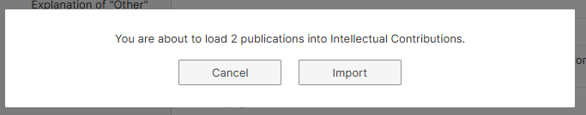
- The import is complete.

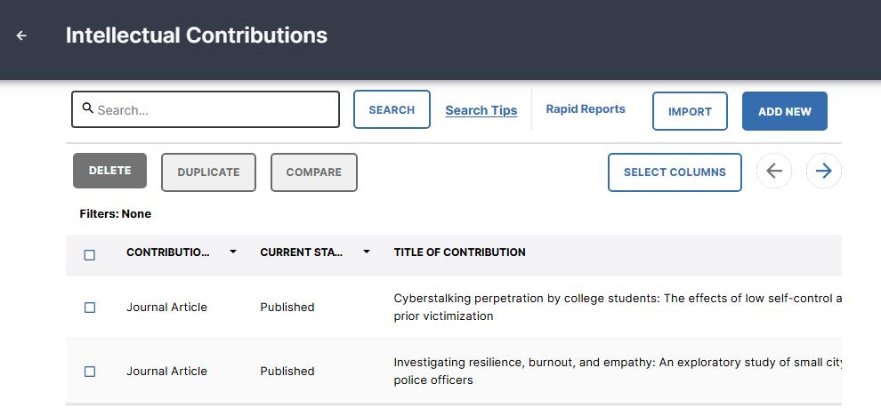

Note: If your screen looks different, you may make changes to the columns displayed on your profile by clicking “Select Columns.” This will affect how your profile looks in Faculty Success. It will not alter the information stored or what will show in reports.

- To make edits to a publication, place your mouse over the publication, and click the small pencil icon.

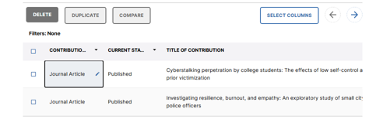

- A window will open on the right side of your browser window. Enter or edit any information. Not all fields need text entered. Refer to the UND Annual Evaluation Report guide to see what is in this report. Also refer to your college guidelines to determine what information they would like you to report.

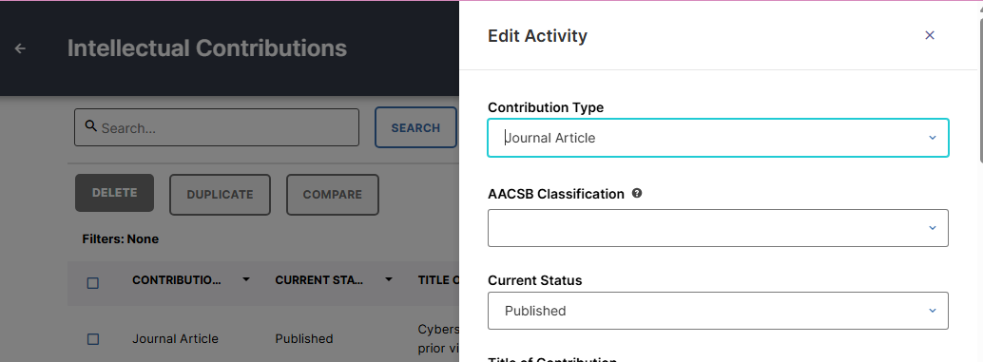

Note: You may also save a full text of the item here. This does not make the item publicly available, it only stores the article in Faculty Success for your records.

- Click “Save” when finished editing.

