Research Imports – ORCID
This guide provides instructions for linking your ORCID account and importing research citations into your Faculty Success profile.
Updated: July 22, 2026

If you do not have an ORCID profile, you can register and link your publications HERE.
- Log in to your Faculty Success Profile.

- Go to “My Profile” and scroll to “Intellectual Contributions.”

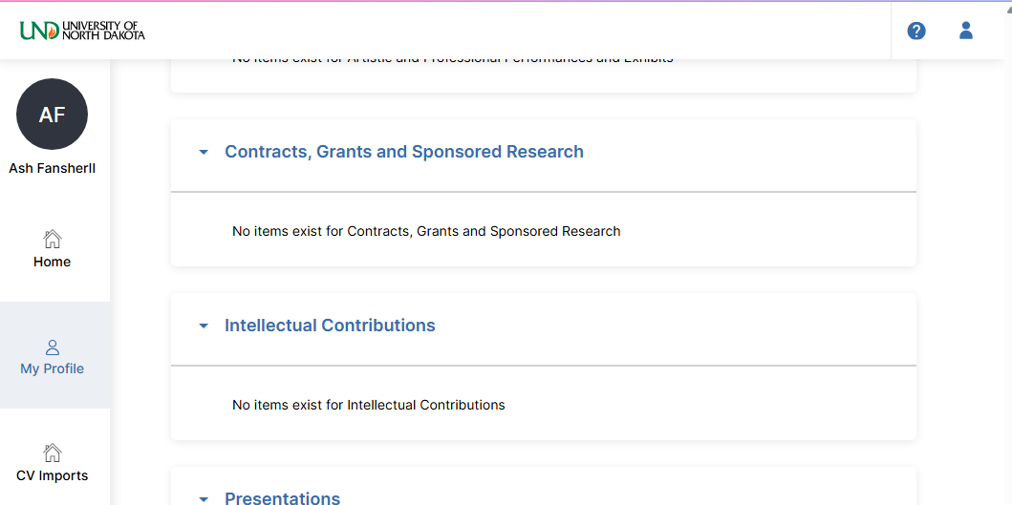

- Select “Import” in the top right corner.

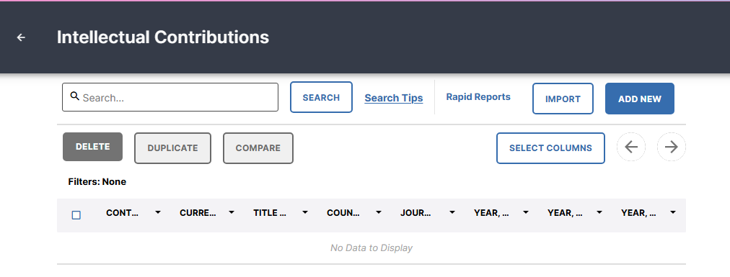

- Under “Import from a Third Party,” select “ORCID.” If you would like to import from Google Scholar or PubMed, please refer to the separate guide.

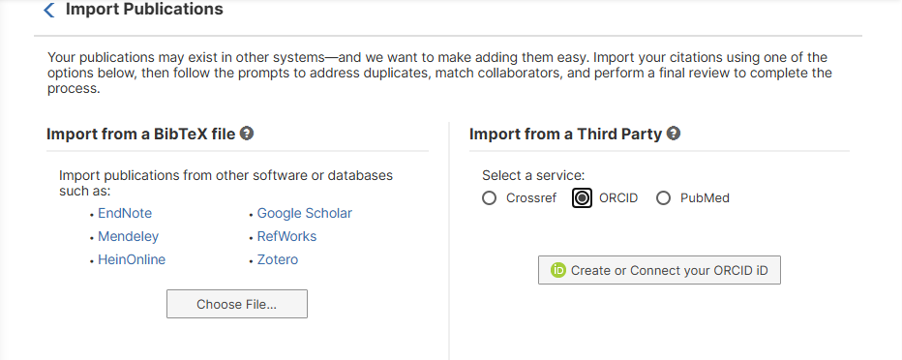

- Click “Create or Connect your ORCID ID.”

- A new window will open asking for your ORCID login information.

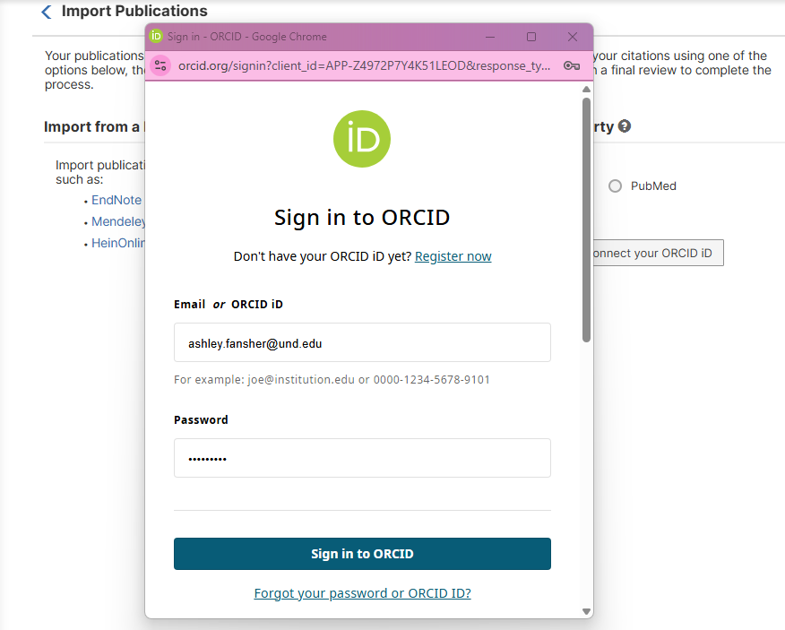

- Sign in to ORCID and authorize access at the bottom of the separate window.

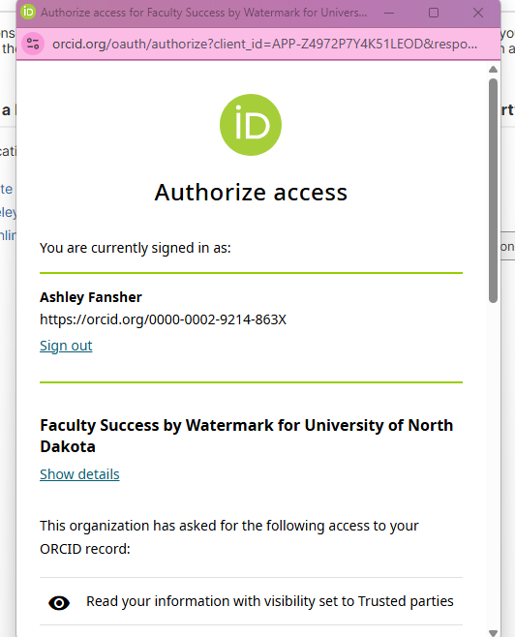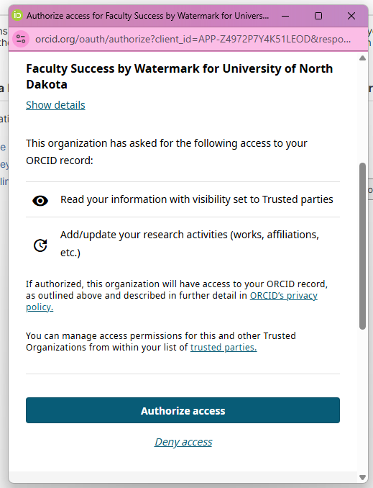

- You will see that your profile is connected to ORCID.

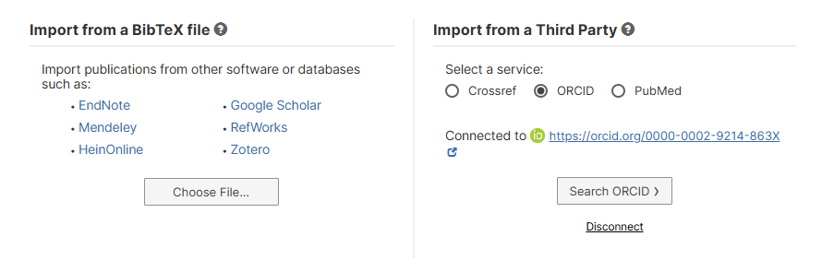

- Search ORCID for publications to import.

- Select the publications you wish to import by clicking the checkboxes next to them.
Note: Publications are not in chronological order.

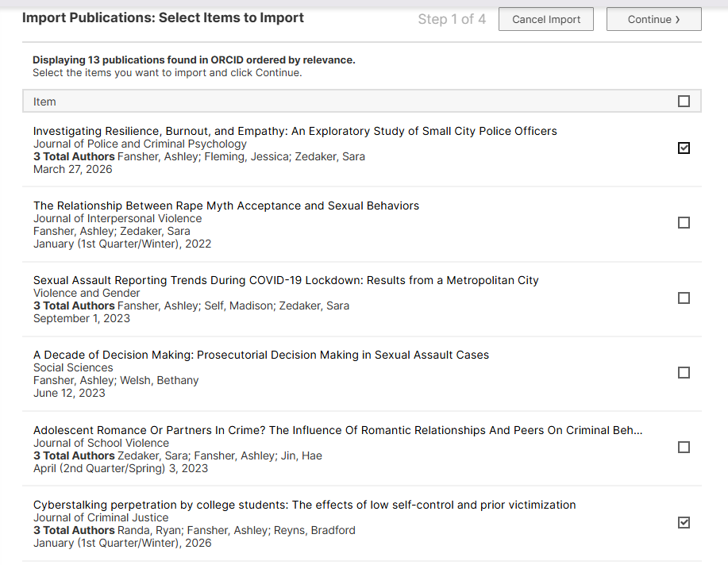

- When you are finished selecting articles, click “Continue” in the top right corner.

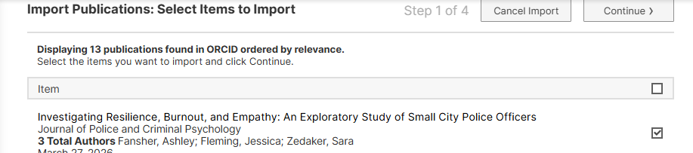

- You will be prompted to link publications to other co-authors who work at University of North Dakota. The screen will list the co-authors for all publications that are being imported. If you would like to link a publication to a UND employee, select “Match to a user account” and locate the co-author.

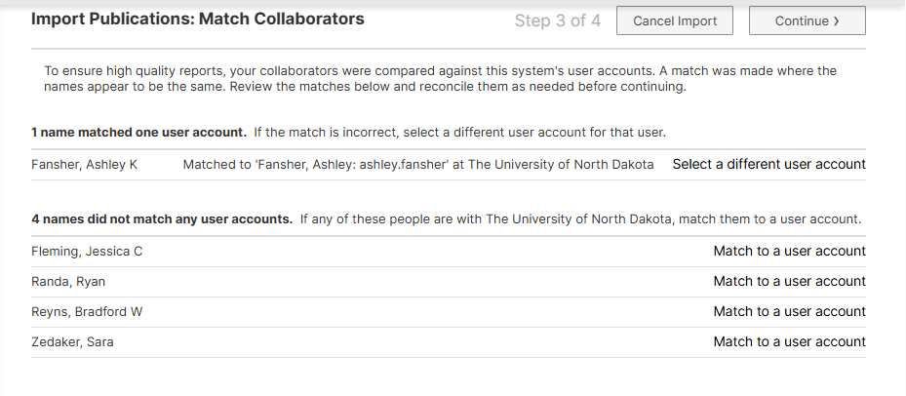
Note: Linking a publication to a UND co-author will populate the publication on their profile as well. They may delete the addition if they do want it to appear. It is not required to link co-authors. If you skip this step, the other authors may enter the information on their own.

When you are done linking co-authors, or if you have no co-authors to link, select “Continue.”

- You will be asked to review the information being imported. This screen does not allow you to edit the entry. Review the information, making a note of any information you would like to edit. Click the arrows to review each publication.

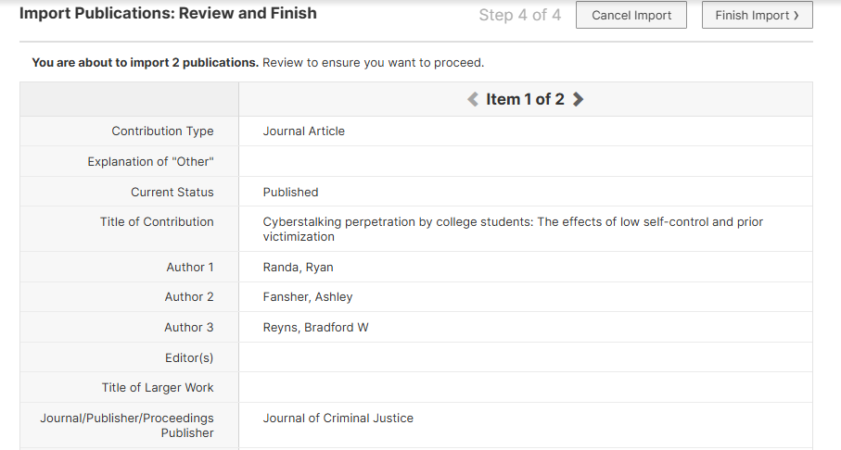

- When you are finished reviewing, select “Finish Import.”

- Confirm the import.

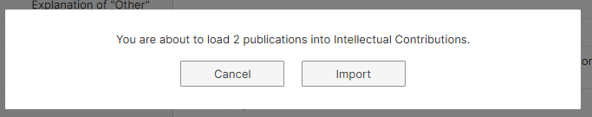
- The import is complete.

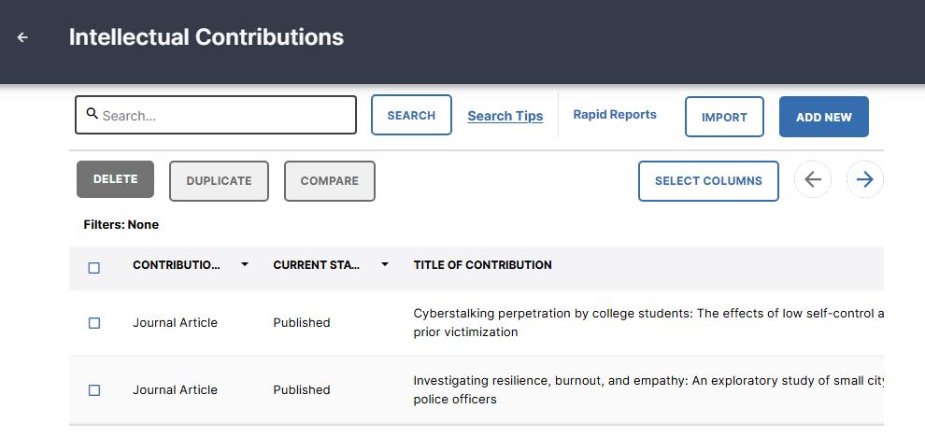

Note: If your screen looks different, you may make changes to the columns displayed on your profile by clicking “Select Columns.” This will affect how your profile looks in Faculty Success. It will not alter the information stored or what will show in reports.

- To make edits to a publication, place your mouse over the publication, and click the small pencil icon.

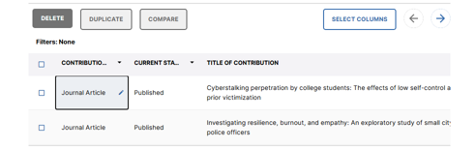

- A window will open on the right side of your browser window. Enter or edit any information. Not all fields need text entered. Refer to the UND Annual Evaluation Report guide to see what is in this report. Also refer to your college guidelines to determine what information they would like you to report.

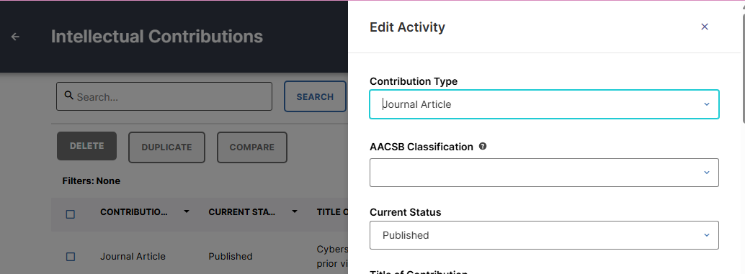

Note: You may also save a full text of the item here. This does not make the item publicly available, it only stores the article in Faculty Success for your records.

- Click “Save” when finished editing.

