# SETTING THE DOCUMENT LANGUAGE

## Microsoft Word & Excel

To set the document language in a Microsoft Word and Excel document, go to **File**.

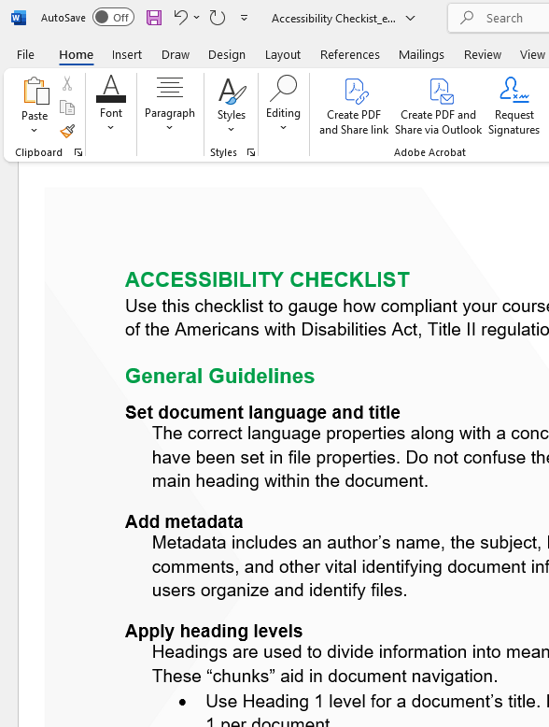

Navigate down to the **Options** tab.

null


On the Options pane, select the **Language** tab. Choose what language you prefer for both display purposes and reading and proofing purposes. You may have to download a language extension for less common languages.

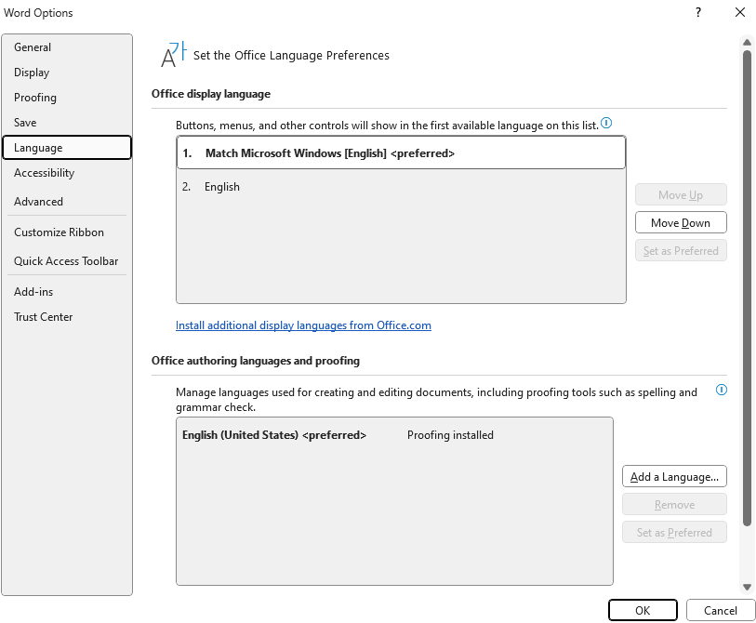

## Microsoft PowerPoint

To set the language for a PowerPoint document, navigate to the **Review** tab. Select **Language**. In the dropdown menu, select **Language Preferences**.

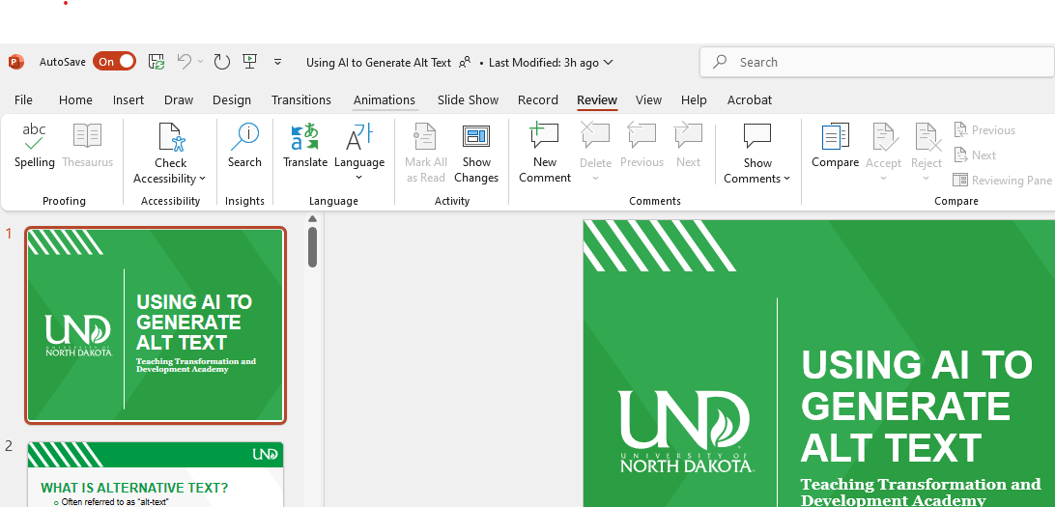

Inside the **Language** pane, select the language you need.

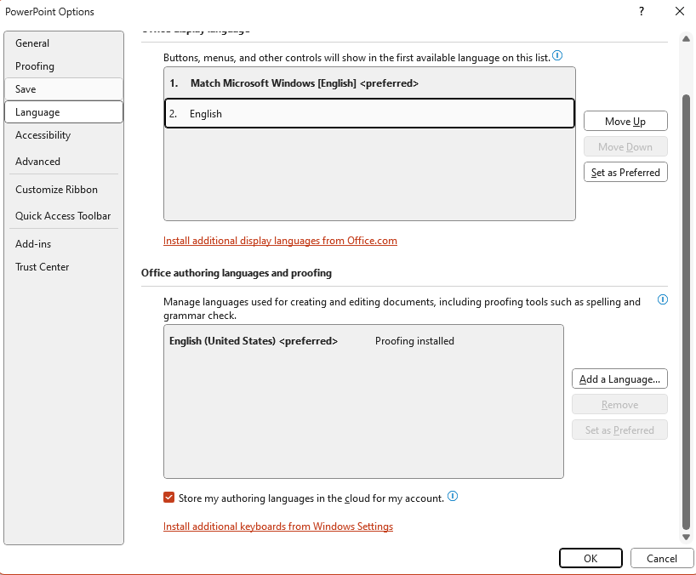

## Adobe Acrobat

To set the document language in Adobe Acrobat (PDF), navigate to the **Menu** tab. Select **Document properties**.

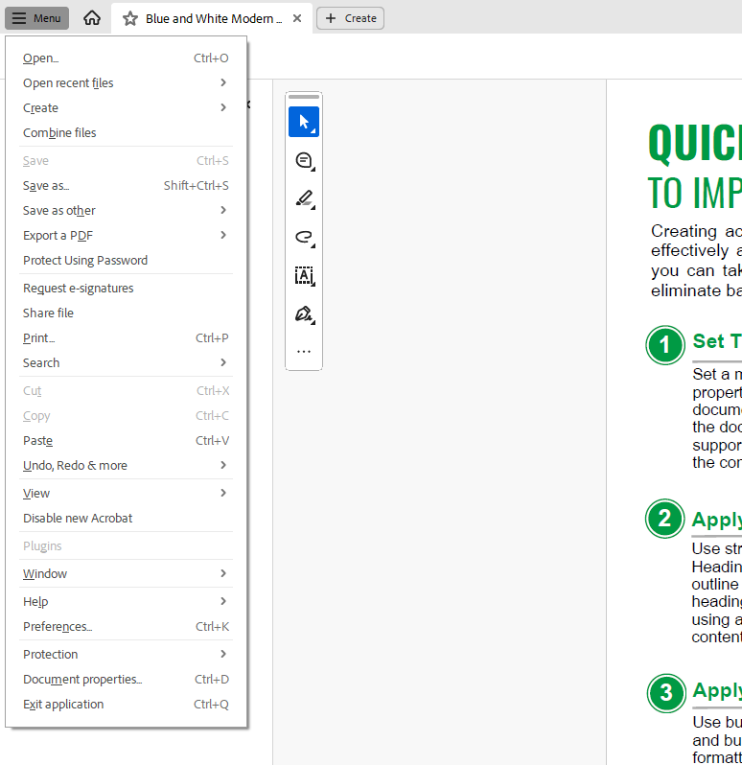

In the **Document Properties** box, select **Advanced**. Enter the language in the Language field under Reading Options. This essentially sets the document’s primary language in the metadata.

