# SETTING THE DOCUMENT TITLE

## Microsoft Word, Excel, & PowerPoint

To set the document title in a Microsoft Office document, go to **File** and down at the bottom of the context menu, select **Properties**.

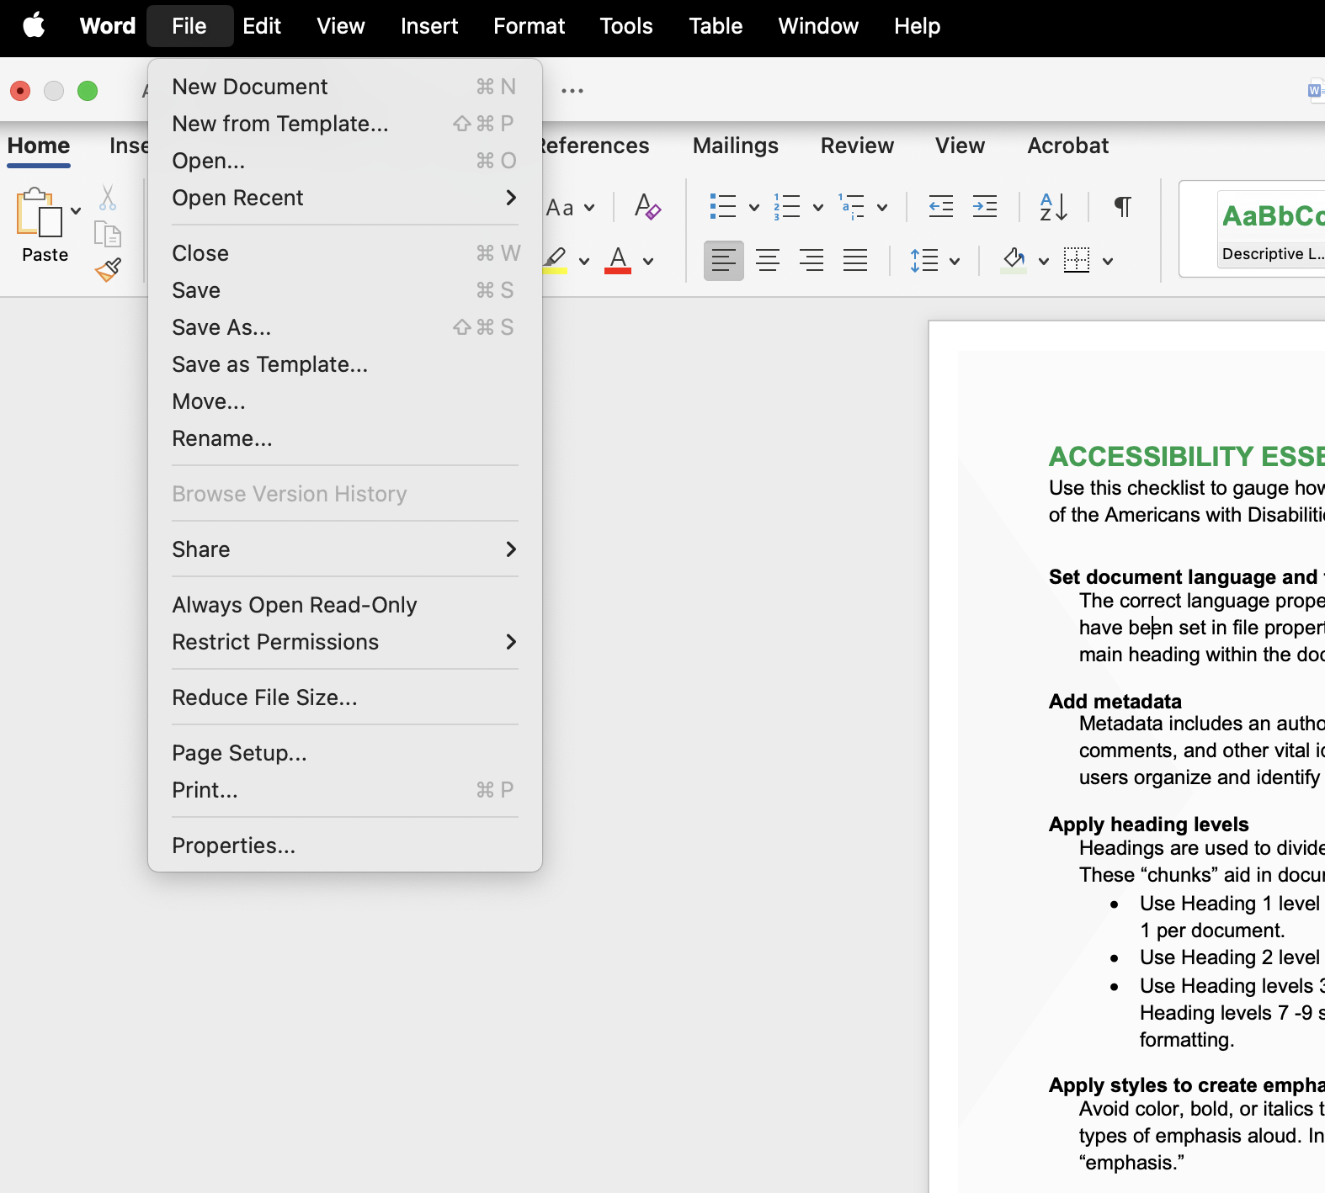

In the **Properties**dialogue box, select Summary and enter the document title in the **Title** field.

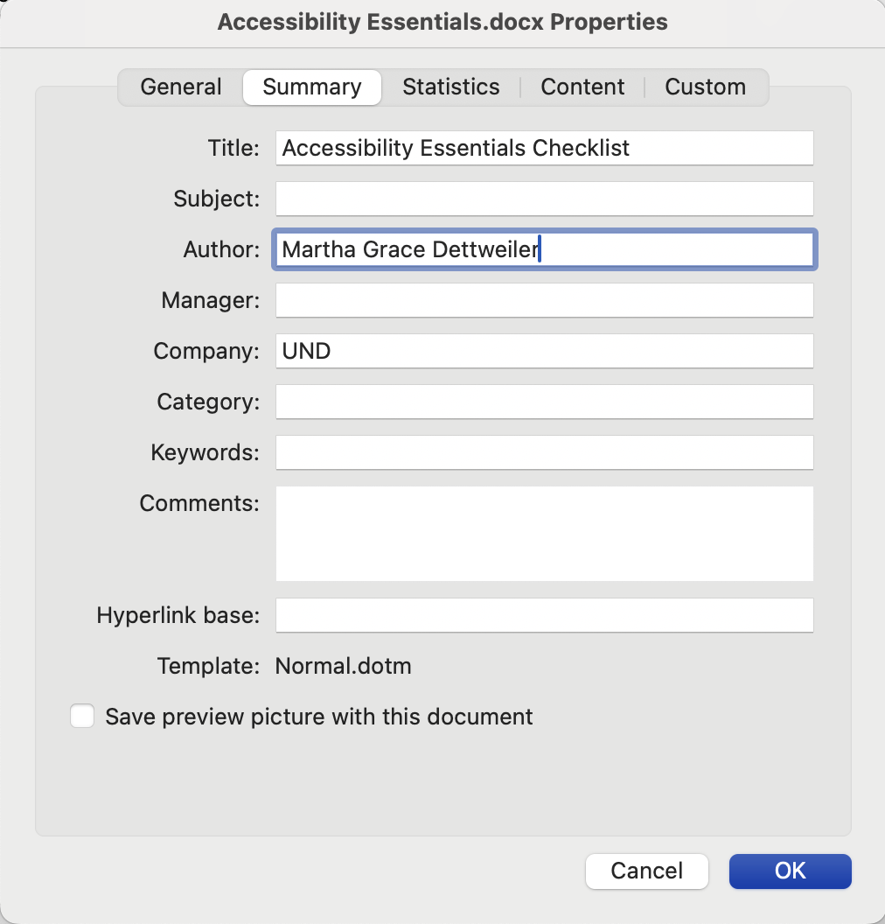

## Adobe Acrobat

To set the document title in Adobe Acrobat (PDF), go to **File**. Near the end of the menu, select **Document properties**.

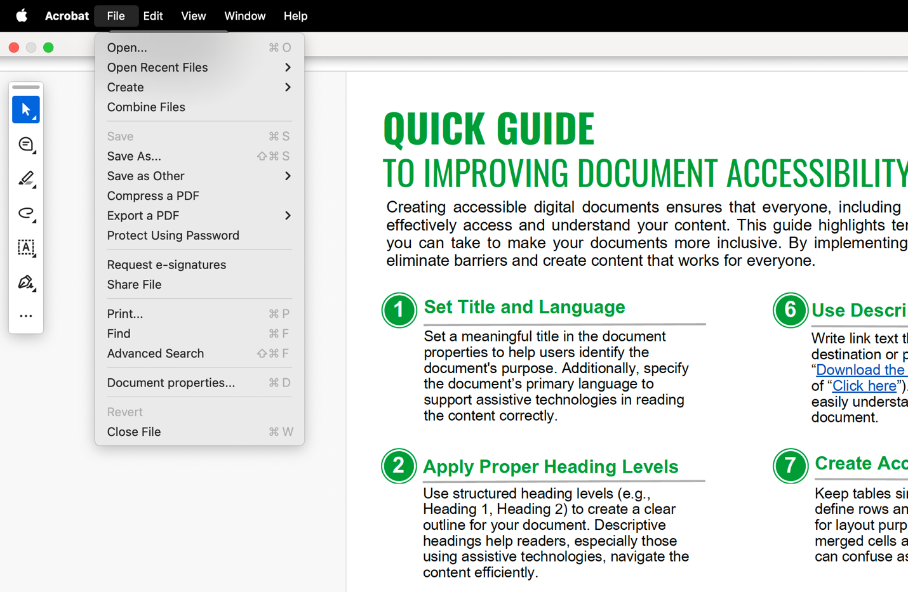

In the **Document Properties** box, select **Description**. Enter the title in the **Title** field.

