# SETTING THE DOCUMENT TITLE

## Microsoft Word, Excel, & PowerPoint

To set the document title in a Microsoft Office document, go to **File**.

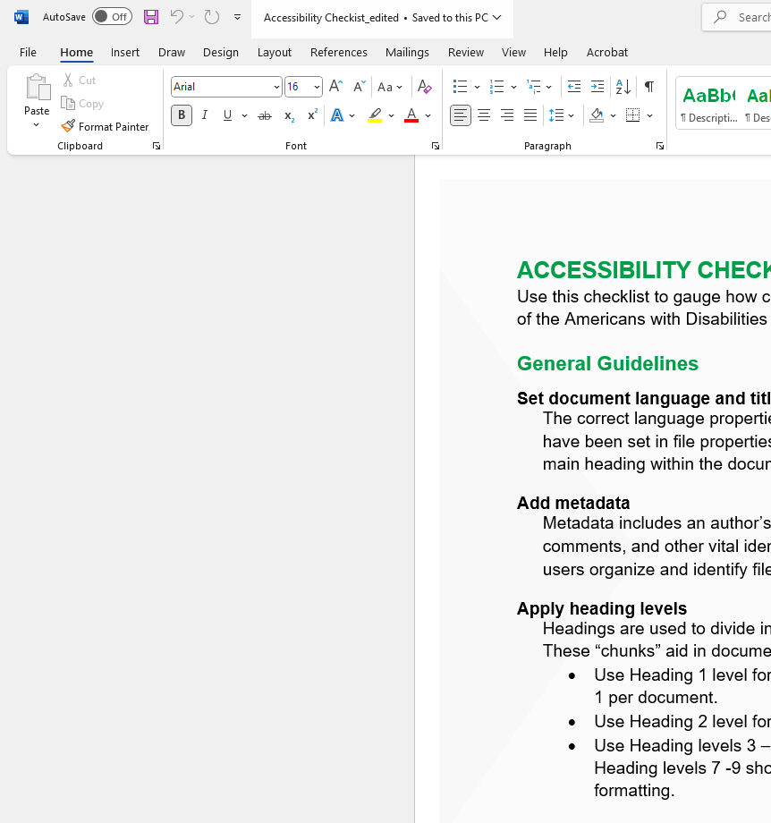

Navigate down to the **Info** tab.

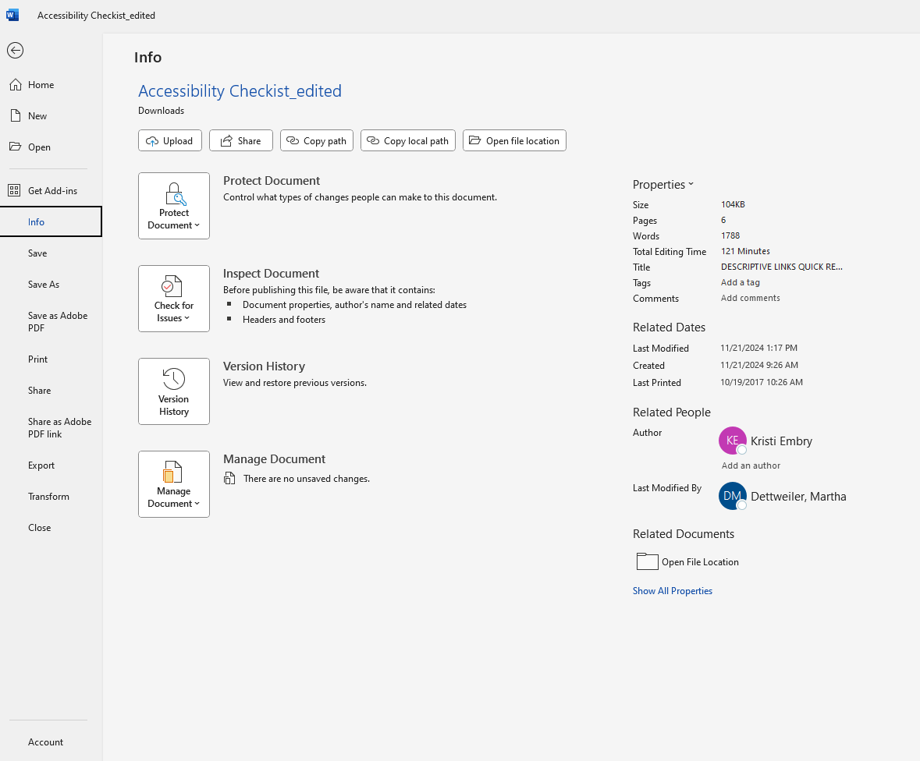

On the right-hand side of the screen, select the **Title** field. Double click to edit the text in this field.

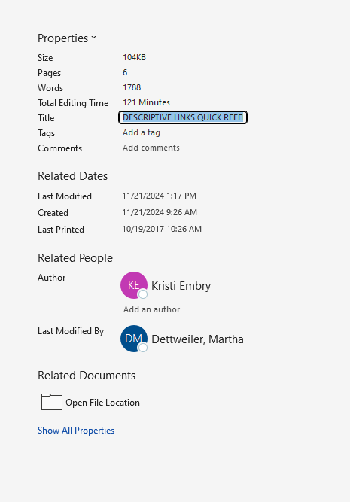

## Adobe Acrobat

To set the document title in Adobe Acrobat (PDF), navigate to the **Menu** tab. Select **Document properties**.

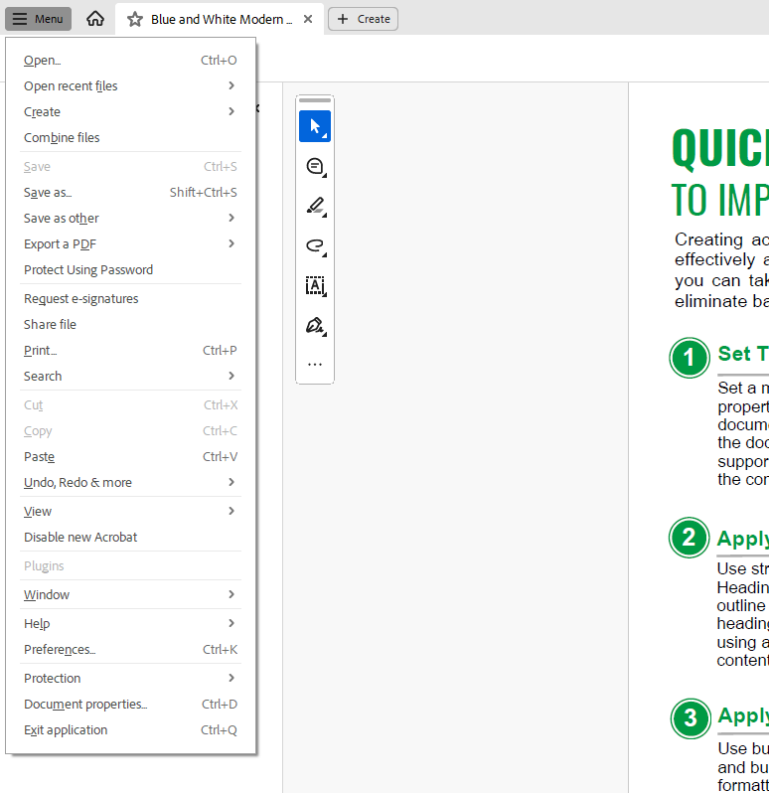

In the **Document Properties** box, select **Description**. Enter the title in the **Title** field.

