# Complex Image Example 2: Long Description in an Appendix

## Chapter 1

Lorem ipsum dolor sit amet, consectetur adipiscing elit, sed do eiusmod tempor incididunt ut labore et dolore magna aliqua. Ut enim ad minim veniam, quis nostrud exercitation ullamco laboris nisi ut aliquip ex ea commodo consequat. Duis aute irure dolor in reprehenderit in voluptate velit esse cillum dolore eu fugiat nulla pariatur. Excepteur sint occaecat cupidatat non proident, sunt in culpa qui officia deserunt mollit anim id est laborum.

### Table : Percent of Iraq Media Sources

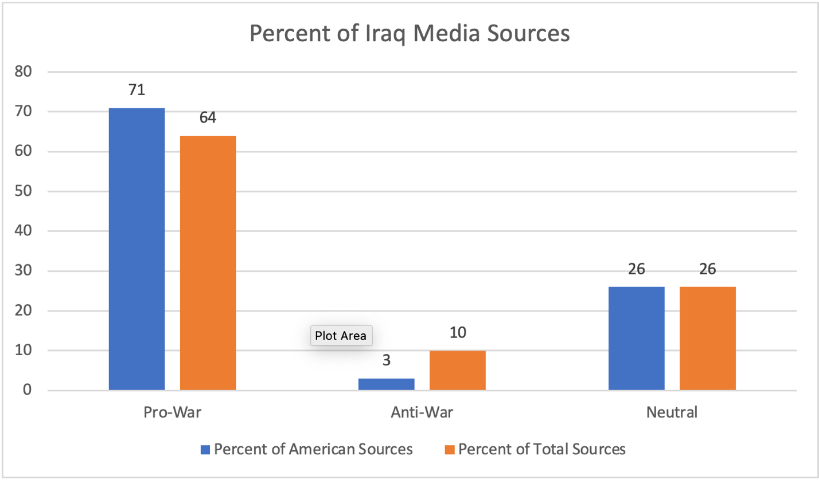

See the complete description of this chart

## Appendix 1

In their analysis of the media coverage of the Iraq War, Steve Rendell and Tara Broughel concluded that media’s attitudes toward the war were not universally consistent. Indeed, Rendell and Broughel show that coverage varied between pro-war, neutral, and anti-war. The sources they evaluated were largely pro-war, with American news sources coming in at 71% and total sources coming in at 64%. Neutral coverage came in at 26% for both American and other media sources. Anti-war attitudes were slight, with a mere 3% of American sources and 10% total sources opposing the war.

Return to Percent of Iraq Media Sources

## Works Cited

Rendell Steve and Tara Broughel. “Amplifying Officials, Squelching Dissent.” *FAIR*. May

1, 2003.