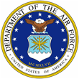 |  | 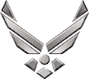
U N I T E D S T A T E S A I R F O R C E

LIEUTENANT COLONEL CORY R. TURNER

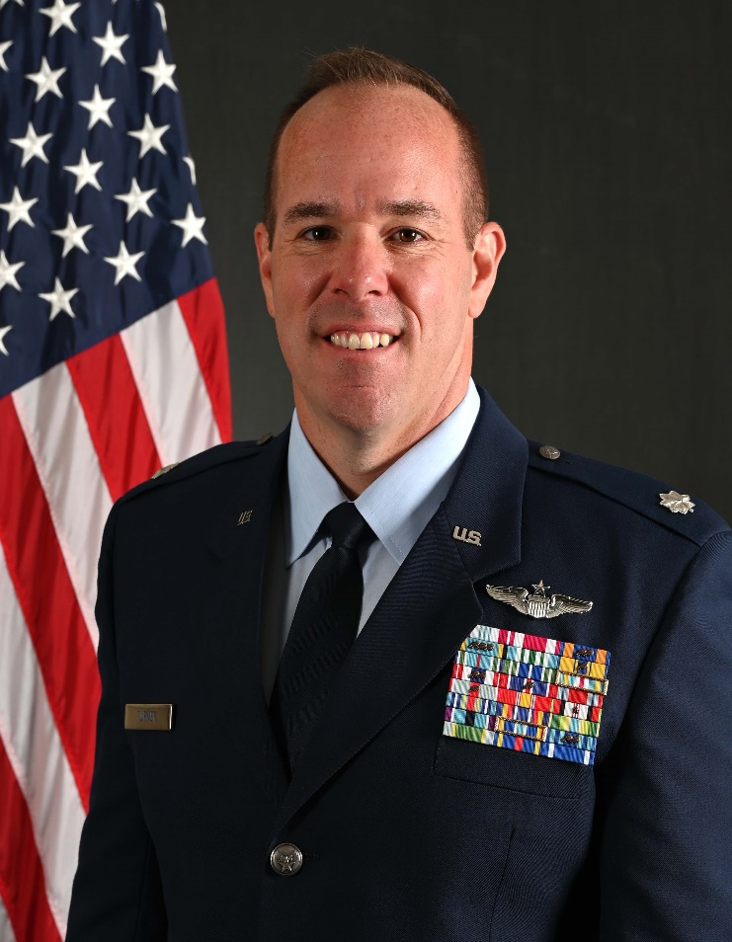
Lt Col Cory Turner is the Commander, 348th Reconnaissance Squadron at Grand Forks Air Force, North Dakota. He is responsible for leading the 24/7 globally employed high altitude long endurance RQ-4 Global Hawk ISR mission that generate over 6,000 flight hours annually. He leads a diverse team that seamlessly executes POTUS authorized missions daily, supporting four combatant commanders providing deterrence against the top five adversaries listed in the National Defense Strategy. Lt Col Turner also support the flying missions at each of the RQ-4 Forward Operating Locations in Europe and the Pacific.

Lt Col Turner was commissioned in the Air Force in 2007 through Air Force ROTC at Texas Tech University, Lubbock, Tx. He attended Undergraduate Pilot Training at Laughlin AFB, Tx., graduating in 2009. Upon graduation, he began his flying career in the KC-10, where he deployed multiple times in support of Operation Iraqi Freedom, Operation Enduring Freedom, Operation New Dawn, Operation Odyssey Dawn, and various operations in the Horn of Africa. Following his time with the KC-10, Lt Col Turner moved to the RQ-4, where he helped stand up the 348th Reconnaissance Squadron and served as the 69th Reconnaissance Group Executive Officer. He would later become the first U.S. pilot and member of the initial cadre at the NATO Alliance Ground Surveillance Force, Naval Air Station Sigonella, Italy. After his assignment with NATO, he began conducting developmental and operational test evaluations. As Chief of the C2ISR Operational Test Division at the Air Force Operational Test and Evaluation Center, Edwards AFB, CA, Lt Col Turner was responsible for testing various emerging technologies such as the Air Force Vanguard Program Skyborg and conducted the RQ-4B Block 30 Operational Test and Evaluation shortly before its divesture. Cory also has experience planning and executing Personnel Recovery operations.

Lt Col Turner is a Command Pilot with more than 2,300 flight hours, including more than 1,300 combat and combat support hours. Lt Col Turner is married to former McCall Nipp of Amarillo, Tx. They have two children, Tripp and Trierre.

EDUCATION
2007 Bachelor of Arts in Public Relations and Mass Communication, Texas Tech University, Lubbock, Tex.
2014 Squadron Officer School (In Residence), Maxwell AFB, Ala.
2017 Master of Aeronautical Science, Embry-Riddle Aeronautical University, Daytona Beach, Fla.
2018 Air Command and Staff College (Correspondence), Maxwell AFB, Ala.
2018 Joint and Combined Warfighter School, National Defense University, Norfolk, Vir.
2023 Air War College (Correspondence), Maxwell AFB, Ala.

ASSIGNMENTS
- Aug 2007 – June 2008, Standards and Evaluations Liaison Officer, 58th Airlift Squadron, Altus AFB, Okla.
- July 2008 – July 2009, Student, Undergraduate Pilot Training, Laughlin AFB, Texas
- July 2009 – September 2012, Aircraft Commander, KC-10, 9th Air Refueling Squadron, Travis AFB, Calf.
- January 2013 – September 2015, Executive Officer, 69th Reconnaissance Group, Grand Forks AFB, No Dak.
- September 2015 – October 2018, Chief of Force Training and Director of U.S. Joint Manpower, NATO Alliance Ground Surveillance Force, Naval Air Station Sigonella, Italy
- October 2018 – May 2020, RQ-4 Operational Test Director, Air Force Operational Test Center, Edwards AFB, Calf.
- May 2020 – November 2020, Director, Joint Personnel Recovery Center, Joint Task Force-Bavo, Soto-Cano Air Base, Honduras
- November 2020 – July 2021, Chief, Command and Control Intelligence, Surveillance and Reconnaissance Test Division, Air Force Operational Test and Evaluation Center, Edwards AFB, Calf.
- July 2021 – January 23, Director of Operations, 4th Reconnaissance Squadron, Andersen AFB, Guam
- February – May 23, Commander, 4th Reconnaissance Squadron, Andersen AFB, Guam
- July 23 – Present, Commander, 348th Reconnaissance Squadron, Grand Forks AFB, North Dakota

FLIGHT INFORMATION
Rating: Senior Pilot
Flight hours: More than 2,300 (980 Combat, 360 Combat Support)
Aircraft flown: T-6, T-1A, KC-10, RQ-4B

MAJOR AWARDS AND DECORATIONS
Defense Meritorious Service Medal
Meritorious Service Medal with one oak leaf cluster
Air Medal with two oak leaf clusters
Aerial Achievement Medal with three oak leaf clusters
Joint Commendation Medal
Air Force Commendation Medal
Joint Achievement Medal
Army Achievement Medal Meritorious Unit Award

EFFECTIVE DATES OF PROMOTION
Second Lieutenant August 2007
First Lieutenant November 2009
Captain November 2011
Major September 2017
Lieutenant Colonel December 2021

(Current as of Mar 2024)

